Machine Learning-Based Graduate Admission Prediction Framework

ABSTRACT
Graduate admission prediction is an important application of machine learning that can assist students and educational institutions in estimating admission opportunities based on historical admission data. This paper presents a Machine Learning-Based Graduate Admission Prediction Framework designed to analyze admission-related data and predict the admission percentage of prospective applicants. The proposed framework processes a dataset containing more than 8,000 records and performs extensive data analysis and visualization to understand admission patterns across specialization, gender, region, university ratings, and admission percentages. The preprocessing stage identifies missing values, applies data processing and normalization, and divides the dataset into 80% training and 20% testing subsets. Multiple machine learning and deep learning algorithms, including CNN2D, Support Vector Machine, Decision Tree, Random Forest, K-Nearest Neighbors, and Linear Regression, are implemented and evaluated. Model performance is measured using Mean Squared Error (MSE) and R² score to assess prediction accuracy and the difference between predicted and actual admission values. Among the evaluated models, the CNN2D model achieves an MSE of 0.018 and an R² score of 98.11, with its predicted admission percentages closely matching the actual test values. Comparative graphs and tabular results are used to analyze the performance of all models. The framework also supports uploading test data and generating admission percentage predictions using the trained CNN2D model. The results demonstrate the applicability of machine learning and deep learning techniques for data-driven graduate admission prediction.
KEYWORDS
Graduate Admission Prediction, Machine Learning, Deep Learning, CNN2D, Admission Percentage, Data Preprocessing, Data Normalization, Predictive Analytics, Model Comparison, Educational Data Mining.
INTRODUCTION
Graduate admission is an important decision-making process for students, universities, and educational institutions because it determines the suitability and potential of applicants for advanced academic programs. The admission process generally involves analyzing several factors associated with applicants, universities, regions, specializations, and previous academic information. With the increasing availability of educational datasets, machine learning techniques can be used to identify patterns within historical admission records and support data-driven prediction. Traditional admission assessment may require considerable effort when a large number of applicants and multiple attributes need to be analyzed simultaneously. A machine learning-based prediction framework can process historical data systematically and generate admission-related predictions based on learned patterns. Such systems can also provide visualization and statistical analysis to understand the distribution of admission information. Therefore, the application of machine learning and deep learning for graduate admission prediction provides an approach for analyzing large-scale admission data and estimating admission percentages in a structured and computationally efficient manner.

The proposed Machine Learning-Based Graduate Admission Prediction Framework focuses on analyzing graduate admission data and predicting the admission percentage of prospective applicants. The framework works with a dataset containing more than 8,000 records and incorporates several stages, including dataset loading, statistical analysis, visualization, preprocessing, normalization, model training, performance evaluation, and prediction. The dataset can be examined using statistical measures and graphical representations to understand the characteristics of the available attributes. Admission patterns can be analyzed according to different factors, including specialization, gender, region, university ratings, and admission percentage. Such analysis provides an understanding of how admission-related information is distributed within the dataset before applying predictive models. The framework also checks the dataset for missing values and performs appropriate data processing and normalization. By organizing the data before model training, the system prepares the available admission information for machine learning and deep learning algorithms and establishes a structured workflow for subsequent prediction and comparative evaluation.

An important component of the framework is the implementation and comparison of multiple predictive algorithms. The system incorporates CNN2D, Support Vector Machine (SVM), Decision Tree, Random Forest, K-Nearest Neighbors (KNN), and Linear Regression to investigate their ability to predict graduate admission percentages. CNN2D is implemented as a multi-layer deep learning model to learn relationships within the processed input data, while the other algorithms provide alternative machine learning approaches for comparative analysis. Before training, the processed dataset is divided into training and testing subsets using an 80% training and 20% testing ratio. The trained models are evaluated using Mean Squared Error (MSE) and R² score. MSE measures the difference between predicted and actual test values, whereas R² score represents the degree to which the model explains the variation in the target prediction. This evaluation process makes it possible to examine the prediction behavior of each algorithm using consistent performance measures and to identify differences in their resulting admission percentage predictions.

The experimental results demonstrate the capability of the implemented models to perform graduate admission percentage prediction. Among the evaluated approaches, the CNN2D model achieves an MSE of 0.018 and an R² score of 98.11 in the documented experiment. The comparison between actual test admission percentages and CNN2D-predicted percentages shows that the predicted values closely follow the actual values. The prediction graph further illustrates a small difference between the actual and predicted admission percentages, indicating close agreement in the test results. Other evaluated algorithms also provide useful prediction performance, with the Decision Tree, Random Forest, KNN, SVM, and Linear Regression producing their respective evaluation results. The framework presents these results through graphical and tabular comparisons, allowing the performance of the different algorithms to be examined systematically. Such comparative evaluation is useful for understanding how different machine learning approaches behave when applied to the same graduate admission prediction task and provides a clear basis for analyzing MSE and R² performance across the implemented models.

In addition to model training and evaluation, the framework provides a practical prediction mechanism for new test data. After the models are trained, a test data file can be uploaded to obtain admission percentage predictions using the trained CNN2D model. This functionality extends the framework from experimental model comparison to an application-oriented prediction process in which input data can be processed and evaluated to generate an estimated admission percentage. The overall framework combines data analysis, visualization, preprocessing, normalization, machine learning, deep learning, performance evaluation, and prediction within a unified workflow. By integrating these stages, the system provides a structured approach to graduate admission analysis and prediction. The framework demonstrates the usefulness of educational data mining and predictive analytics for extracting meaningful patterns from admission records and generating data-driven predictions. Consequently, the proposed system provides a comprehensive computational framework for analyzing graduate admission information and evaluating multiple machine learning techniques for admission percentage prediction.

OBJECTIVES OF THE PROJECT
- To develop a machine learning-based framework for analyzing graduate admission data and predicting the admission percentage of prospective applicants.
- To preprocess and normalize admission data by checking missing values, performing data processing, and preparing the dataset for effective model training.
- To analyze admission patterns based on attributes such as specialization, gender, region, university ratings, and admission percentage through statistical analysis and visualization.
- To implement and evaluate multiple algorithms, including CNN2D, Support Vector Machine, Decision Tree, Random Forest, K-Nearest Neighbors, and Linear Regression for graduate admission prediction.
- To compare model performance using Mean Squared Error (MSE) and R² score and analyze the differences between actual and predicted admission percentages.
- To provide an admission prediction mechanism that accepts test data and generates admission percentage predictions using the trained CNN2D model.

LITERATURE SURVEY:
Predicting Chance of Admission: A Machine Learning Perspective
Suma Ghosh; Aritra Dey, 2025
Today’s dynamic higher education climate makes it harder to get into a Master’s degree. Our study employs machine learning algorithms to develop a prediction model that helps people make decisions and select universities that align with their academic objectives in order to get over this uncertainty problem. This study is based on an extensive data set that comprises the academic profiles of 400 students.The original dataset encountered a significant challenge in the application of machine learning techniques, particularly concerning the train-test split for predictive modelling, which made it difficult to assess the model’s performance on unseen data. Furthermore, the response variable was not normally distributed, which is a prerequisite for fitting linear regression with continuous data values. Augmented with 1600 more entries, our dataset guarantees a more thorough assessment of prediction models, alleviating constraints and strengthening the validity of our conclusions while preserving the correlation between the characteristics’ underlying pattern. By analyzing MSE and R-squared values, we compare model performances across a variety of institutional kinds. Our study contributes valuable insights about predictive modeling in graduate admissions.
Advanced Graduate Admission Prediction
Srujan Nalam; Mohd Aleemuddin; Yuva Teja Kadari; Nanda Kumar M, 2023
The process of choosing and narrowing down universities for graduate program admission plays a crucial role in the overall application procedure. This project aims to examine the uses of machine learning models to predict the likelihood of a student being accepted into a master's program. Hence this will provide students with an early indication of their admission prospects. In the past, models were constructed using different algorithms such as random forest, multiple linear regression and k-nearest neighbor. Results have shown that logistic regression out performs these algorithms. The admission of students into educational institutions is a critical issue, and this study addresses the application of machine learning algorithms to predict the chance of admission of students into master's programs. These models include SVM, Gaussian Naive Bayes, and Logistic Regression, with experiments demonstrating that the Logistic Regression model surpasses the others. This will give students a better understanding of their admission prospects in advance.
Graduate Admission Prediction Using Machine Learning
Sara Aljasmi, Ali Bou Nassif, Ismail Shahin, Ashraf M Elnagar, 2020
Student admission problem is very important in educational institutions. This paper addresses machine learning models to predict the chance of a student to be admitted to a master’s program. This will assist students to know in advance if they have a chance to get accepted. The machine learning models are multiple linear regression, k-nearest neighbor, random forest, and Multilayer Perceptron. Experiments show that the Multilayer Perceptron model surpasses other models.
Systematic ensemble model selection approach for educational data mining
MohammadNoor Injadat, Abdallah Moubayed, Ali Bou Nassif , Abdallah Shami, 2020
A plethora of research has been done in the past focusing on predicting student’s performance in order to support their development. Many institutions are focused on improving the performance and the education quality; and this can be achieved by utilizing data mining techniques to analyze and predict students’ performance and to determine possible factors that may affect their final marks. To address this issue, this work starts by thoroughly exploring and analyzing two different datasets at two separate stages of course delivery (20% and 50% respectively) using multiple graphical, statistical, and quantitative techniques. The feature analysis provides insights into the nature of the different features considered and helps in the choice of the machine learning algorithms and their parameters. Furthermore, this work proposes a systematic approach based on Gini index and $p$-value to select a suitable ensemble learner from a combination of six potential machine learning algorithms. Experimental results show that the proposed ensemble models achieve high accuracy and low false positive rate at all stages for both datasets.
Prediction of Graduate Admission using Multiple Supervised Machine Learning Models
Zain Bitar; Amjed Al-Mousa, 2020
In response to the highly competitive job market at present times, an increased interest in graduate studies has arisen. This has not only burdened applicants but also led to an increased workload on admission faculty members of universities. Any chance of abridging the admission process impelled applicants and faculty workers to look for faster, efficient, and more accurate methods for predicting admissions. The goal approach of this paper is to implement and compare several supervised predictive analysis methods on a labeled dataset based on real applications from the prestigious university of UCLA; Regression, classification, and Ensemble methods are all the supervised methods that are to be employed for prediction. The dataset relies profoundly on the academic performance of the applicants during their undergrad years. The coefficient of determination, as well as precision and accuracy, are the measures used to compare the different models. All predictive methods proved to show accurate results, however; certain methods proved to be more promising than others were. Predictions were obtained within short time frames, which in turn will cut down the time in the admission process.
A Comparison of Regression Models for Prediction of Graduate Admissions
Mohan S Acharya; Asfia Armaan; Aneeta S Antony, 2019
Prospective graduate students always face a dilemma deciding universities of their choice while applying to master's programs. While there are a good number of predictors and consultancies that guide a student, they aren't always reliable since decision is made on the basis of select past admissions. In this paper, we present a Machine Learning based method where we compare different regression algorithms, such as Linear Regression, Support Vector Regression, Decision Trees and Random Forest, given the profile of the student. We then compute error functions for the different models and compare their performance to select the best performing model. Results then indicate if the university of choice is an ambitious or a safe one.
Predicting Graduate Admission from Important Parameters
Nabin Kumar Karki, 2019
This paper details the development of a predictive statistical model designed to estimate an applicant's chance of graduate school admission. Focused on an Indian student perspective, the project utilizes data visualization and regression analysis to identify which academic parameters most heavily influence selection. By utilizing exploratory data analysis (EDA) and backward stepwise regression, the study simplifies a complex profile evaluation into an optimized, five-variable predictive equation with an Adjusted R-squared of 0.8002.
SYSTEM ANALYSIS:
EXISTING SYSTEM
In the existing graduate admission prediction approach, admission-related datasets are analyzed using conventional statistical methods and multiple machine learning algorithms to estimate admission percentages. The available system performs dataset loading, statistical analysis, visualization, preprocessing, normalization, and model training. It evaluates models such as SVM, Decision Tree, Random Forest, KNN, and Linear Regression using MSE and R² score. However, the approach has limitations in handling complex relationships among multiple admission attributes and does not provide the same deep feature-learning capability as a multi-layer CNN2D model. The uploaded project specifically implements CNN2D as a more complex learning model for admission prediction.
DISADVANTAGES:
- Limited Learning of Complex Patterns – Conventional machine learning models may have difficulty learning complex relationships among multiple admission attributes.
- Dependence on Manual Feature Representation – Traditional models generally rely more heavily on the quality and representation of input features rather than automatically learning complex feature relationships.
- Variation in Prediction Accuracy – Different models produce different prediction performance, with some showing larger differences between actual and predicted admission percentages.
- Higher Prediction Error in Some Models – Models with comparatively lower R² performance can produce greater prediction differences, reducing consistency in admission percentage estimation.
- Limited Model Capability for Complex Data – Conventional approaches may not fully exploit the complex patterns available in a large dataset containing more than 8,000 admission records.
PROPOSED SYSTEM
The proposed Machine Learning-Based Graduate Admission Prediction Framework uses a multi-layer CNN2D model as the primary prediction model. The system first loads and analyzes the admission dataset, performs preprocessing and normalization, and divides the data into 80% training and 20% testing sets. The CNN2D model is then trained to predict admission percentages. Its performance is evaluated using MSE and R² score and compared with SVM, Decision Tree, Random Forest, KNN, and Linear Regression. In the documented results, CNN2D achieved an MSE of 0.018 and an R² score of 98.11, while its predicted and actual admission percentages were shown to be closely aligned.
ADVANTAGES:
- Improved Prediction Performance – CNN2D achieved an R² score of 98.11 with an MSE of 0.018 in the documented experiment.
- Complex Pattern Learning – The multi-layer CNN2D architecture is designed to learn complex relationships within the processed admission data.
- Accurate Admission Estimation – The CNN2D prediction graph shows the actual and predicted admission percentages closely overlapping, indicating close agreement between the two values.
- Comprehensive Model Comparison – The framework evaluates CNN2D alongside SVM, Decision Tree, Random Forest, KNN, and Linear Regression using MSE and R², allowing their prediction performance to be compared systematically.
- Practical Prediction Support – The system allows test data to be uploaded and generates admission percentage predictions using the trained CNN2D model.

MODULES DESCRIPTION:
- Dataset Loading and Management – Loads the graduate admission dataset containing more than 8,000 records and displays the available data values for further processing and analysis.
- Dataset Analysis and Visualization – Analyzes the dataset using statistical information such as count, mean, and standard deviation, and visualizes important admission attributes and their high and low values.
- Admission Pattern Analysis – Visualizes admission patterns based on specialization, gender, region, admission percentage, and university ratings to understand variations in graduate admissions.
- Data Preprocessing and Normalization – Checks the dataset for missing values and performs data processing and normalization to prepare the input features for machine learning models. The dataset contains zero missing values in the shown analysis.
- Training and Testing Data Split – Divides the processed dataset into training and testing portions, using 80% of the data for training and 20% for testing.
- CNN2D Model Training – Implements a multi-layer CNN2D model for graduate admission percentage prediction. The model learns patterns from the processed admission data and generates predicted admission percentages.
- Machine Learning Model Training – Trains additional models, including SVM, Decision Tree, Random Forest, KNN, and Linear Regression, to predict admission percentages and provide comparative performance results.
- Model Performance Evaluation – Evaluates the trained models using Mean Squared Error (MSE) and R² score by comparing predicted values with the actual test values.
- Model Comparison – Compares the performance of CNN2D, SVM, Decision Tree, Random Forest, KNN, and Linear Regression using graphical and tabular representations of MSE and R² scores.
- Admission Percentage Prediction – Allows a test data file to be uploaded and uses the trained CNN2D model to generate the corresponding predicted admission percentage for the supplied input data.
SYSTEM ARCHITECTURE:
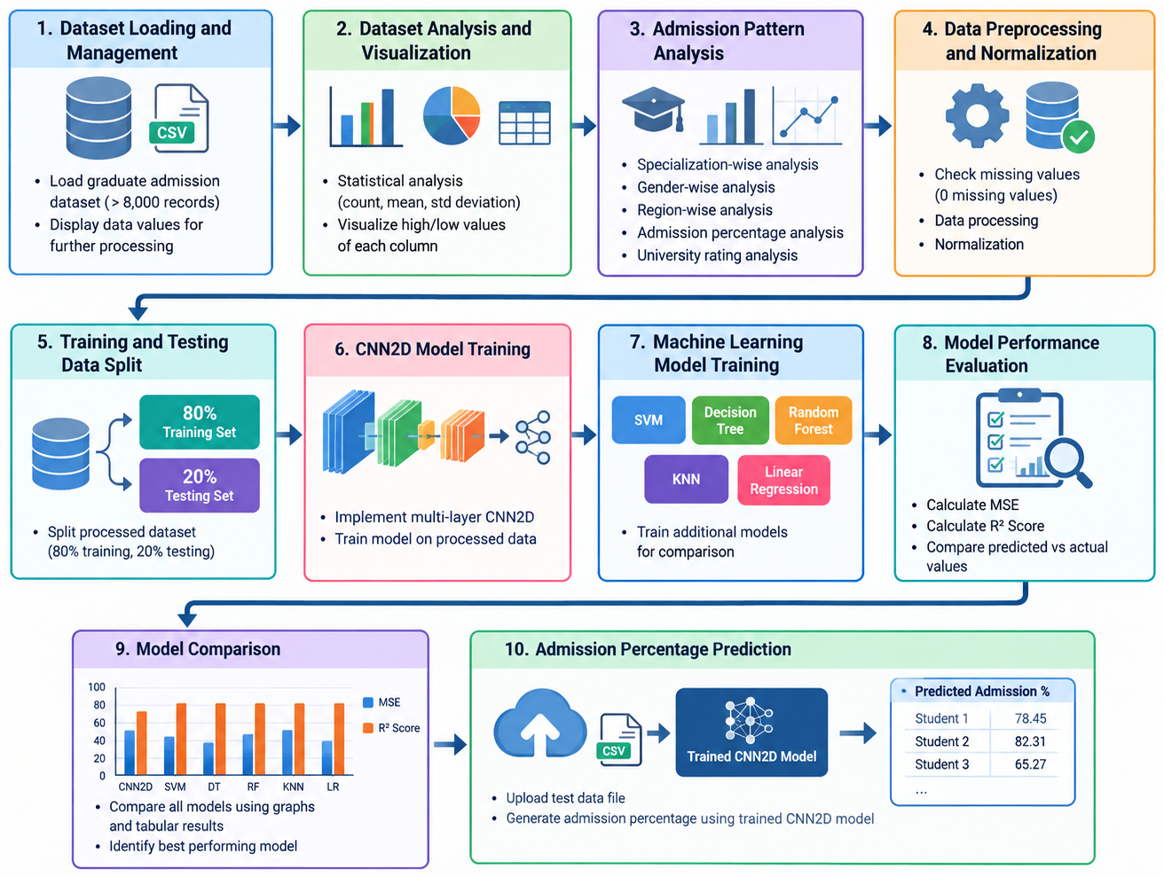
PROCESS MODEL USED WITH JUSTIFICATION
SDLC (Umbrella Model):
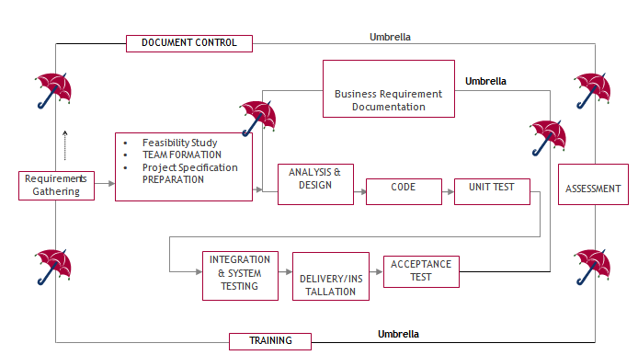
SDLC is nothing but Software Development Life Cycle. It is a standard which is used by software industry to develop good software.

Stages in SDLC:
- Requirement Gathering
- Analysis
- Designing
- Coding
- Testing
- Maintenance

Requirements Gathering stage:
The requirements gathering process takes as its input the goals identified in the high-level requirements section of the project plan. Each goal will be refined into a set of one or more requirements. These requirements define the major functions of the intended application, define operational data areas and reference data areas, and define the initial data entities. Major functions include critical processes to be managed, as well as mission critical inputs, outputs and reports. A user class hierarchy is developed and associated with these major functions, data areas, and data entities. Each of these definitions is termed a Requirement. Requirements are identified by unique requirement identifiers and, at minimum, contain a requirement title and textual description.
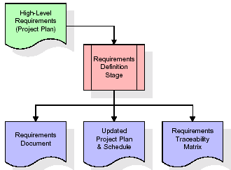
These requirements are fully described in the primary deliverables for this stage: the Requirements Document and the Requirements Traceability Matrix (RTM). The requirements document contains complete descriptions of each requirement, including diagrams and references to external documents as necessary. Note that detailed listings of database tables and fields are not included in the requirements document.
The title of each requirement is also placed into the first version of the RTM, along with the title of each goal from the project plan. The purpose of the RTM is to show that the product components developed during each stage of the software development lifecycle are formally connected to the components developed in prior stages.
In the requirements stage, the RTM consists of a list of high-level requirements, or goals, by title, with a listing of associated requirements for each goal, listed by requirement title. In this hierarchical listing, the RTM shows that each requirement developed during this stage is formally linked to a specific product goal. In this format, each requirement can be traced to a specific product goal, hence the term requirements traceability.
The outputs of the requirements definition stage include the requirements document, the RTM, and an updated project plan.
- Feasibility study is all about identification of problems in a project.
- No. of staff required to handle a project is represented as Team Formation, in this case only modules are individual tasks will be assigned to employees who are working for that project.
- Project Specifications are all about representing of various possible inputs submitting to the server and corresponding outputs along with reports maintained by administrator.

Analysis Stage:
The planning stage establishes a bird's eye view of the intended software product, and uses this to establish the basic project structure, evaluate feasibility and risks associated with the project, and describe appropriate management and technical approaches.
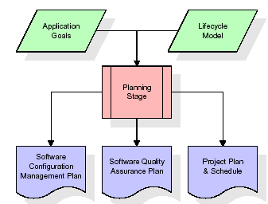
The most critical section of the project plan is a listing of high-level product requirements, also referred to as goals. All of the software product requirements to be developed during the requirements definition stage flow from one or more of these goals. The minimum information for each goal consists of a title and textual description, although additional information and references to external documents may be included. The outputs of the project planning stage are the configuration management plan, the quality assurance plan, and the project plan and schedule, with a detailed listing of scheduled activities for the upcoming Requirements stage, and high level estimates of effort for the out stages.

Designing Stage:
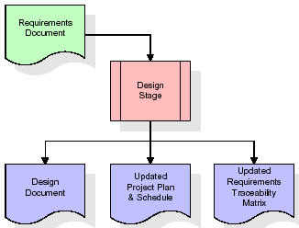
The design stage takes as its initial input the requirements identified in the approved requirements document. For each requirement, a set of one or more design elements will be produced as a result of interviews, workshops, and/or prototype efforts. Design elements describe the desired software features in detail, and generally include functional hierarchy diagrams, screen layout diagrams, tables of business rules, business process diagrams, pseudo code, and a complete entity-relationship diagram with a full data dictionary. These design elements are intended to describe the software in sufficient detail that skilled programmers may develop the software with minimal additional input.
When the design document is finalized and accepted, the RTM is updated to show that each design element is formally associated with a specific requirement. The outputs of the design stage are the design document, an updated RTM, and an updated project plan.
Development (Coding) Stage:
The development stage takes as its primary input the design elements described in the approved design document. For each design element, a set of one or more software artifacts will be produced. Software artifacts include but are not limited to menus, dialogs, and data management forms, data reporting formats, and specialized procedures and functions. Appropriate test cases will be developed for each set of functionally related software artifacts, and an online help system will be developed to guide users in their interactions with the software.
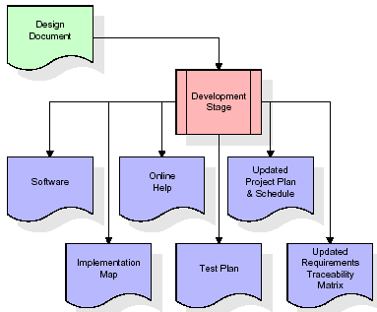

The RTM will be updated to show that each developed artifact is linked to a specific design element, and that each developed artifact has one or more corresponding test case items. At this point, the RTM is in its final configuration. The outputs of the development stage include a fully functional set of software that satisfies the requirements and design elements previously documented, an online help system that describes the operation of the software, an implementation map that identifies the primary code entry points for all major system functions, a test plan that describes the test cases to be used to validate the correctness and completeness of the software, an updated RTM, and an updated project plan.
Integration & Test Stage:
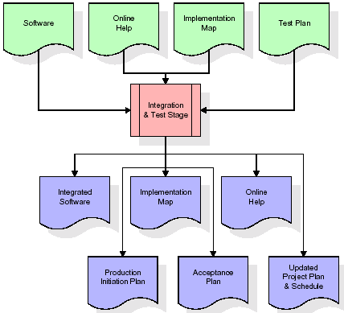
During the integration and test stage, the software artifacts, online help, and test data are migrated from the development environment to a separate test environment. At this point, all test cases are run to verify the correctness and completeness of the software. Successful execution of the test suite confirms a robust and complete migration capability. During this stage, reference data is finalized for production use and production users are identified and linked to their appropriate roles. The final reference data (or links to reference data source files) and production user list are compiled into the Production Initiation Plan.

The outputs of the integration and test stage include an integrated set of software, an online help system, an implementation map, a production initiation plan that describes reference data and production users, an acceptance plan which contains the final suite of test cases, and an updated project plan.
- Installation & Acceptance Test:
During the installation and acceptance stage, the software artifacts, online help, and initial production data are loaded onto the production server. At this point, all test cases are run to verify the correctness and completeness of the software. Successful execution of the test suite is a prerequisite to acceptance of the software by the customer.
After customer personnel have verified that the initial production data load is correct and the test suite has been executed with satisfactory results, the customer formally accepts the delivery of the software.
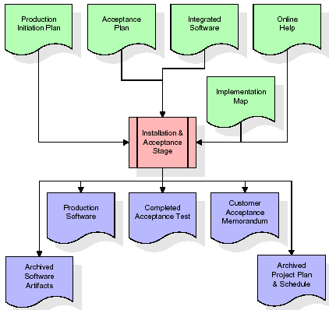
The primary outputs of the installation and acceptance stage include a production application, a completed acceptance test suite, and a memorandum of customer acceptance of the software. Finally, the PDR enters the last of the actual labor data into the project schedule and locks the project as a permanent project record. At this point the PDR "locks" the project by archiving all software items, the implementation map, the source code, and the documentation for future reference.
Maintenance:
Outer rectangle represents maintenance of a project, Maintenance team will start with requirement study, understanding of documentation later employees will be assigned work and they will undergo training on that particular assigned category. For this life cycle there is no end, it will be continued so on like an umbrella (no ending point to umbrella sticks).

Software Requirement Specification
Overall Description
A Software Requirements Specification (SRS) – a requirements specification for a software system is a complete description of the behaviour of a system to be developed. It includes a set of use cases that describe all the interactions the users will have with the software. In addition to use cases, the SRS also contains non-functional requirements. Non-functional requirements are requirements which impose constraints on the design or implementation (such as performance engineering requirements, quality standards, or design constraints).
System requirements specification: A structured collection of information that embodies the requirements of a system. A business analyst, sometimes titled system analyst, is responsible for analysing the business needs of their clients and stakeholders to help identify business problems and propose solutions. Within the systems development lifecycle domain, the BA typically performs a liaison function between the business side of an enterprise and the information technology department or external service providers. Projects are subject to three sorts of requirements:
- Business requirements describe in business terms what must be delivered or accomplished to provide value.
- Product requirements describe properties of a system or product (which could be one of several ways to accomplish a set of business requirements.)
- Process requirements describe activities performed by the developing organization. For instance, process requirements could specify .Preliminary investigation examine project feasibility, the likelihood the system will be useful to the organization. The main objective of the feasibility study is to test the Technical, Operational and Economical feasibility for adding new modules and debugging old running system. All system is feasible if they are unlimited resources and infinite time. There are aspects in the feasibility study portion of the preliminary investigation:
- ECONOMIC FEASIBILITY
A system can be developed technically and that will be used if installed must still be a good investment for the organization. In the economic feasibility, the development cost in creating the system is evaluated against the ultimate benefit derived from the new systems. Financial benefits must equal or exceed the costs. The system is economically feasible. It does not require any addition hardware or software. Since the interface for this system is developed using the existing resources and technologies available at NIC, there is nominal expenditure and economic feasibility for certain.
- Operational Feasibility
Proposed projects are beneficial only if they can be turned out into information system. That will meet the organization’s operating requirements. Operational feasibility aspects of the project are to be taken as an important part of the project implementation. This system is targeted to be in accordance with the above-mentioned issues. Beforehand, the management issues and user requirements have been taken into consideration. So there is no question of resistance from the users that can undermine the possible application benefits. The well-planned design would ensure the optimal utilization of the computer resources and would help in the improvement of performance status.
- TECHNICAL FEASIBILITY
Earlier no system existed to cater to the needs of ‘Secure Infrastructure Implementation System’. The current system developed is technically feasible. It is a web-based user interface for audit workflow at NIC-CSD. Thus, it provides an easy access to. the users. The database’s purpose is to create, establish and maintain a workflow among various entities in order to facilitate all concerned users in their various capacities or roles. Permission to the users would be granted based on the roles specified. Therefore, it provides the technical guarantee of accuracy, reliability and security.
HARDWARE & SOFTWARE REQUIREMENTS:
HARDWARE REQUIRMENTS:
- Processor : intel i3(min)
- Hard Disk : 500 GB.
- Ram : 4 GB (min).
SOFTWARE REQUIRMENTS:
- Operating system : Windows 10 (min)
- Coding Language : python 3.7.0

SYSTEM DESIGN
UML Diagram:
The Unified Modelling Language allows the software engineer to express an analysis model using the modelling notation that is governed by a set of syntactic semantic and pragmatic rules.
A UML system is represented using five different views that describe the system from distinctly different perspective. Each view is defined by a set of diagram, which is as follows.
  - User Model View
    - This view represents the system from the users perspective.
    - The analysis representation describes a usage scenario from the end-users perspective.
  - Structural Model view
    - In this model the data and functionality are arrived from inside the system.
    - This model view models the static structures.
- Behavioural Model View
It represents the dynamic of behavioural as parts of the system, depicting the interactions of collection between various structural elements described in the user model and structural model view.
- Implementation Model View
In this the structural and behavioural as parts of the system are represented as they are to be built.
- Environmental Model View
In this the structural and behavioural aspects of the environment in which the system is to be implemented are represented.
Class Diagram:
The class diagram is the main building block of object oriented modeling. It is used both for general conceptual modeling of the systematic of the application, and for detailed modeling translating the models into programming code. Class diagrams can also be used for data modeling. The classes in a class diagram represent both the main objects, interactions in the application and the classes to be programmed. In the diagram, classes are represented with boxes which contain three parts:
- The upper part holds the name of the class
- The middle part contains the attributes of the class
- The bottom part gives the methods or operations the class can take or undertake.
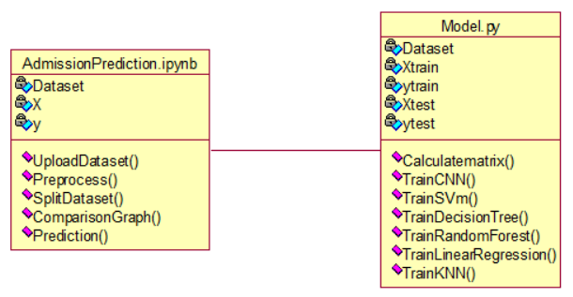
Use case Diagram:
A use case diagram at its simplest is a representation of a user's interaction with the system and depicting the specifications of a use case. A use case diagram can portray the different types of users of a system and the various ways that they interact with the system. This type of diagram is typically used in conjunction with the textual use case and will often be accompanied by other types of diagrams as well.

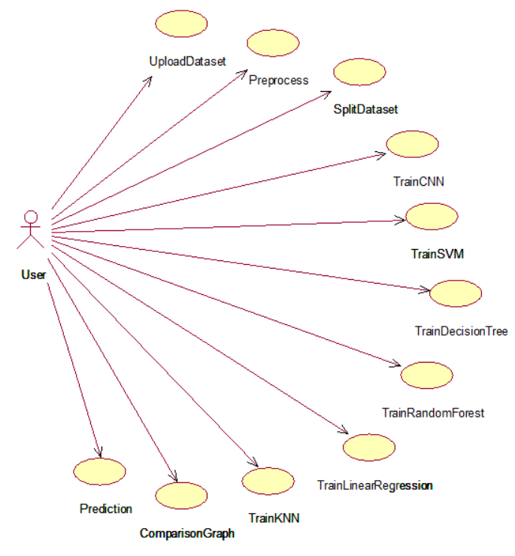

Sequence diagram:
A sequence diagram is a kind of interaction diagram that shows how processes operate with one another and in what order. It is a construct of a Message Sequence Chart. A sequence diagram shows object interactions arranged in time sequence. It depicts the objects and classes involved in the scenario and the sequence of messages exchanged between the objects needed to carry out the functionality of the scenario. Sequence diagrams are typically associated with use case realizations in the Logical View of the system under development. Sequence diagrams are sometimes called event diagrams, event scenarios, and timing diagrams.
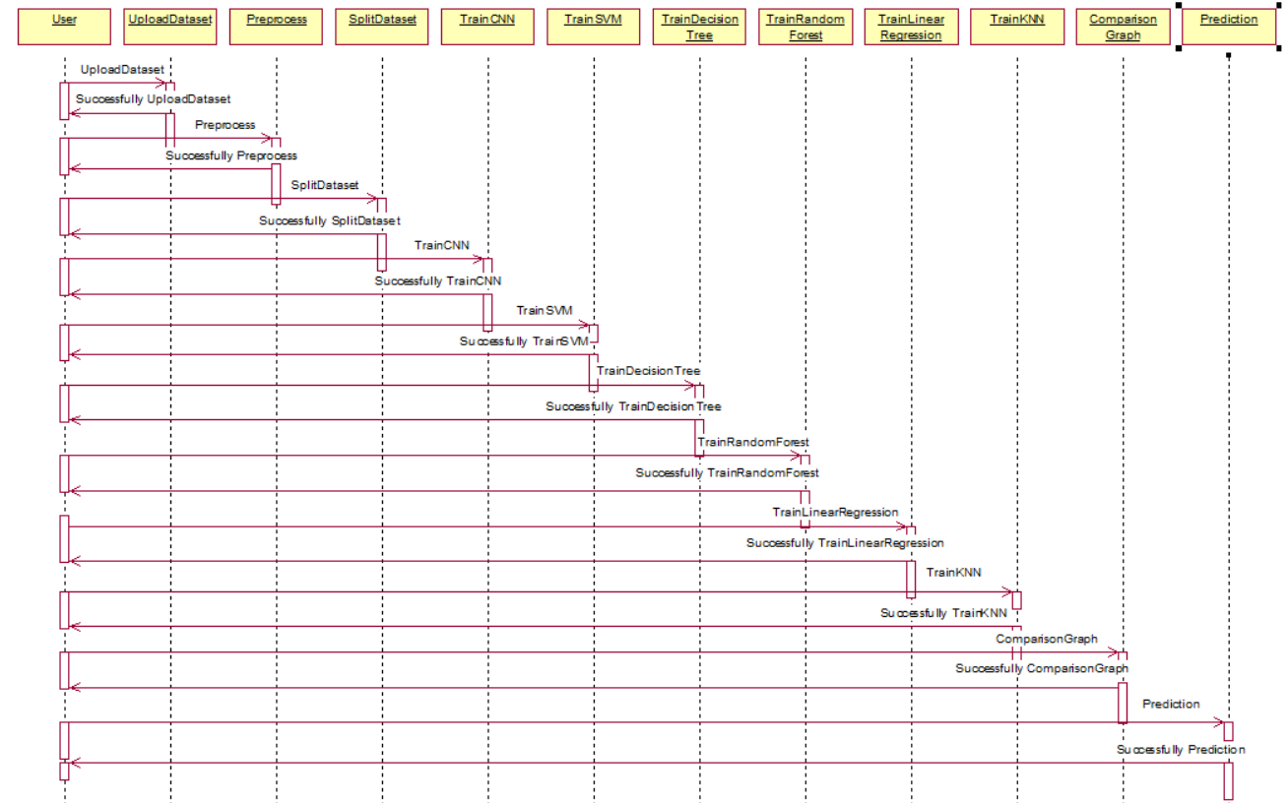
Collaboration diagram:
A collaboration diagram describes interactions among objects in terms of sequenced messages. Collaboration diagrams represent a combination of information taken from class, sequence, and use case diagrams describing both the static structure and dynamic behaviour of a system.
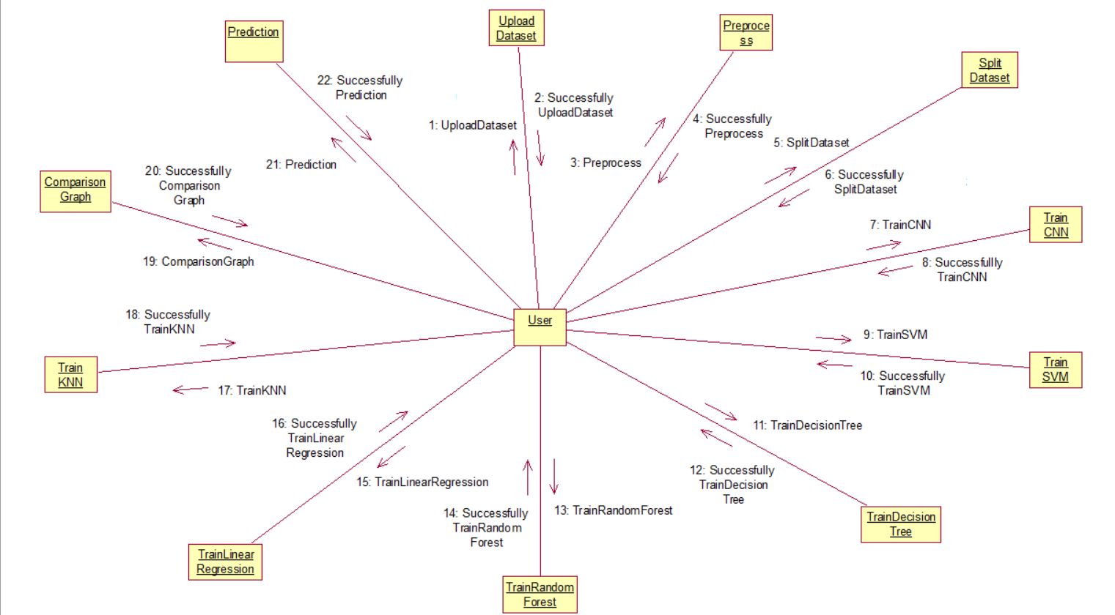
Component Diagram:
In the Unified Modelling Language, a component diagram depicts how components are wired together to form larger components and or software systems. They are used to illustrate the structure of arbitrarily complex systems.
Components are wired together by using an assembly connector to connect the required interface of one component with the provided interface of another component. This illustrates the service consumer - service provider relationship between the two components.
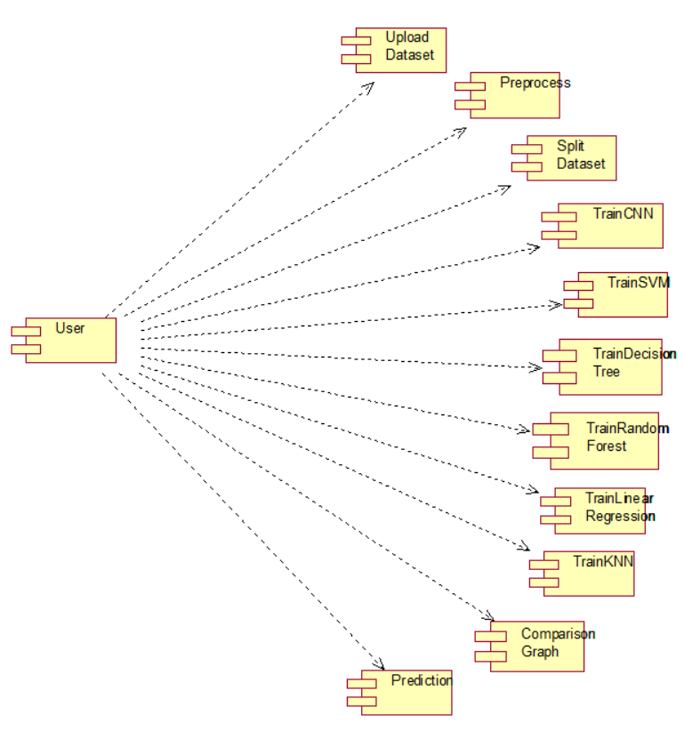
Deployment Diagram:
A deployment diagram in the Unified Modeling Language models the physical deployment of artifacts on nodes. To describe a web site, for example, a deployment diagram would show what hardware components ("nodes") exist (e.g., a web server, an application server, and a database server), what software components ("artifacts") run on each node (e.g., web application, database), and how the different pieces are connected (e.g. JDBC, REST, RMI).
The nodes appear as boxes, and the artifacts allocated to each node appear as rectangles within the boxes. Nodes may have sub nodes, which appear as nested boxes. A single node in a deployment diagram may conceptually represent multiple physical nodes, such as a cluster of database servers.
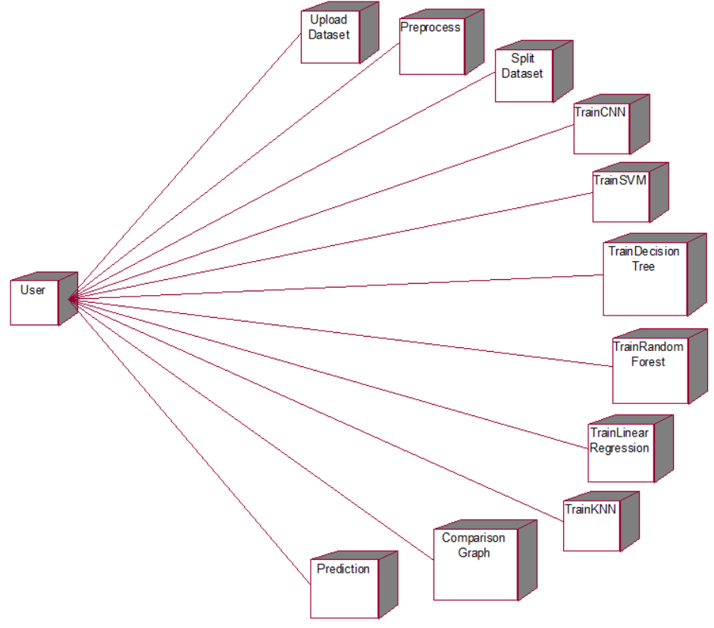
Activity Diagram:
Activity diagram is another important diagram in UML to describe dynamic aspects of the system. It is basically a flow chart to represent the flow form one activity to another activity. The activity can be described as an operation of the system. So, the control flow is drawn from one operation to another. This flow can be sequential, branched or concurrent
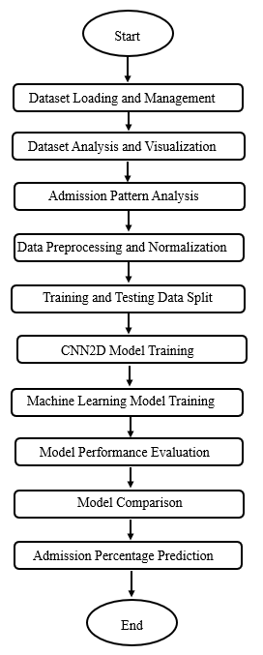

Data Flow Diagram:
Data flow diagrams illustrate how data is processed by a system in terms of inputs and outputs. Data flow diagrams can be used to provide a clear representation of any business function. The technique starts with an overall picture of the business and continues by analyzing each of the functional areas of interest. This analysis can be carried out in precisely the level of detail required. The technique exploits a method called top-down expansion to conduct the analysis in a targeted way.

As the name suggests, Data Flow Diagram (DFD) is an illustration that explicates the passage of information in a process. A DFD can be easily drawn using simple symbols. Additionally, complicated processes can be easily automated by creating DFDs using easy-to-use, free downloadable diagramming tools. A DFD is a model for constructing and analyzing information processes. DFD illustrates the flow of information in a process depending upon the inputs and outputs. A DFD can also be referred to as a Process Model. A DFD demonstrates business or technical process with the support of the outside data saved, plus the data flowing from the process to another and the end results.
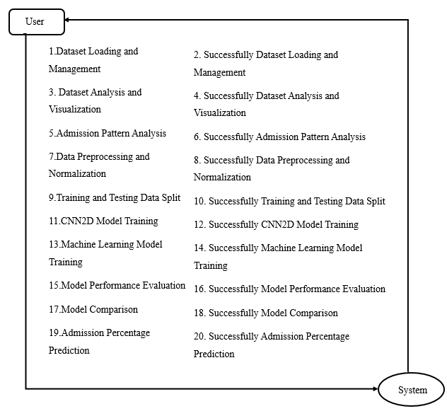
IMPLEMETATION:
PYTHON
* One of the most popular languages is Python. Guido van Rossum released this language in 1991. Python is available on the Mac, Windows, and Raspberry Pi operating systems. The syntax of Python is simple and identical to that of English. When compared to Python, it was seen that the other language requires a few extra lines.
*It is an interpreter-based language because code may be run line by line after it has been written. This implies that rapid prototyping is possible across all platforms. Python is a big language with a free, binary-distributed interpreter standard library.
* It is inferior to maintenance that is conducted and is straightforward to learn. It is an object-oriented, interpreted programming language. It supports several different programming paradigms in addition to object-oriented programming, including functional and procedural programming.
* It supports several different programming paradigms in addition to object-oriented programming, including practical and procedural programming. Python is mighty while maintaining a relatively straightforward syntax. Classes, highly dynamic data types, modules, and exceptions are covered. Python can also be utilised by programmes that require programmable interfaces as an external language.
Here are some key features and characteristics of Python:
- Readability: Python emphasizes code readability with its clean and intuitive syntax. It uses indentation and whitespace to structure code blocks, making it easy to understand and maintain.
- Easy to Learn: Python's simplicity and readability make it an excellent choice for beginners. Its straightforward syntax and extensive documentation make it accessible for newcomers to programming.
- Interpreted Language: Python is an interpreted language, meaning that it doesn't need to be compiled before running. The Python interpreter reads and executes the code directly, making the development process faster and more interactive.
- Cross-platform Compatibility: Python is available for major operating systems like Windows, macOS, and Linux. This cross-platform compatibility allows developers to write code once and run it on different platforms without modifications.
- Large Standard Library: Python comes with a vast standard library that provides ready-to-use modules and functions for various tasks. It covers areas such as file I/O, networking, regular expressions, databases, and more, saving developers time and effort.
- Extensible and Modular: Python supports modular programming, enabling developers to organize code into reusable modules and packages. Additionally, Python allows integrating modules written in other languages, such as C or C++, providing flexibility and performance optimizations.
- Wide Range of Libraries and Frameworks: Python has a vibrant ecosystem with numerous third-party libraries and frameworks. These libraries, such as NumPy, pandas, TensorFlow, and Django, extend Python's capabilities for specific domains, making it a powerful tool for diverse applications.
- Object-Oriented: Python supports object-oriented programming (OOP) principles, allowing developers to create and work with classes and objects. OOP provides a structured approach to code organization, promoting code reuse and modularity.
- Dynamic Typing: Python is dynamically typed, meaning variable types are determined at runtime. Developers do not need to declare variable types explicitly, which enhances flexibility and simplifies code writing.
5.2 Installation
To install Python on your computer, follow these basic steps:
- Step 1: Visit the Python website Go to the official Python website at https://www.python.org/.
- Step 2: Select the operating system Choose the appropriate installer for your operating system. Python supports Windows, macOS, and various Linux distributions. Make sure to select the correct version that matches your operating system.
- Step 3: Check which version of Python is installed; if the 3.7.0 version is not there, uninstall it through the control panel and
- Step 4: Install Python 3.7.0 using Cmd.
- Step 5: Install the all libraries that required to run the project
- Step 6: Run
5.3 Python Features:
- Easy: Because Python is a more accessible and straightforward language, Python programming is easier to learn.
- Interpreted language: Python is an interpreted language;therefore it can be used to examine the code line by line and provide results.
- Open Source: Python is a free online programming language since it is open-source.
- Portable: Python is portable because the same code may be used on several computer standard
- libraries: Python offers a sizable library that we may utilize to create applications quickly.
- GUI: It stands for GUI (Graphical User Interface)
- Dynamical typed: Python is a dynamically typed language; therefore the type of the value will be determined at runtime.
5.4 Python IDLE
- Python IDLE offers a full-fledged file editor, which gives you the ability to write and execute Python programs from within this program. The built-in file editor also includes several features, like code completion and automatic indentation, that will speed up your coding workflow.
- Guido Van Rossum named Python after the British comedy group Monty Python while the name IDLE was chosen to pay tribute to Eric Idle, who was one of the Monty Python's founding members. IDLE comes bundled with the default implementation of the Python language since the 01.5. 2b1 release
- IDLE is used to execute statements similar to Python Shell. IDLE is used to create, modify, and execute Python code. IDLE provides a fully-featured text editor to write Python scripts and provides features like syntax highlighting, auto-completion, and smart indent.
- IDLE has two modes: interactive and script. We wrote our first program, “Hello, World!” in interactive mode. Interactive mode immediately returns the results of commands you enter into the shell. In script mode, you will write a script and then run it.
- The IDE Python IDLE is a good place to start as it helps you become familiar with the way Python works and understand its syntax. This IDE is good to start programming in Python due to its great debugger, but once you are fluent and start developing projects it is necessary to jump to another, more complete IDE.
- Python IDLE (Integrated Development and Learning Environment) is an interactive development environment included with the Python programming language. It provides a convenient way to write, execute, and debug Python code.
When you install Python, IDLE is typically installed along with it. To open IDLE, you can follow these steps:
- Open the command prompt (Windows) or terminal (macOS/Linux).
- Type "idle" and press Enter. Alternatively, you can specify the version with "idle3" or "idle2" for Python 3 or Python 2, respectively.
- Once IDLE is launched, you will see the Python shell, which is an interactive environment where you can type and execute Python code directly.
Here are some features and functionalities provided by Python IDLE:
- Editor: IDLE includes a text editor where you can write your Python code. It offers syntax highlighting, automatic indentation, and code completion to enhance your coding experience.
- Interactive Shell: The Python shell in IDLE allows you to execute Python code interactively. You can type commands, statements, or function calls directly in the shell, and Python will execute them immediately.
- Debugging: IDLE provides basic debugging capabilities to help you find and fix errors in your code. You can set breakpoints, step through code, inspect variables, and track the program's execution.
- Python Help: IDLE provides access to the Python documentation and built-in help. You can access the help menu to find information about Python modules, functions, classes, and more.
- Script Execution: In addition to the interactive shell, IDLE allows you to run Python scripts stored in files. You can write your code in the editor and execute it as a script to see the output or interact with the program.
- Customization: IDLE can be customized to suit your preferences. You can modify settings related to syntax highlighting, indentation, fonts, and more.
- Python IDLE serves as a beginner-friendly development environment and learning tool. It is suitable for writing small scripts, testing code snippets, experimenting with Python features, and learning the language's basics. However, for more advanced development projects, you may consider using other code editors or integrated development environments (IDEs) that provide additional features and better project management capabilities.
5.5 Libraries
In Python, libraries (also referred to as modules or packages) are collections of pre-written code that provide additional functionality and tools to extend the capabilities of the Python language. Libraries contain reusable code that developers can leverage to perform specific tasks without having to write everything from scratch.
Python libraries are designed to solve common problems, such as handling data, performing mathematical operations, interacting with databases, working with files, implementing networking protocols, creating graphical user interfaces (GUIs), and much more. They provide ready-to-use functions, classes, and methods that simplify complex operations and save development time.
Libraries in Python offer various advantages:
- Code Reusability
- Efficiency
- Collaboration
- Domain-Specific Functionality
- To use a Python library, you need to install it first.

There are some libraries following:
- NumPy:
The NumPy Python library for multi-dimensional, big-scale matrices adds a huge number of high-level mathematical functions. It is possible to modify NumPy by utilizing a Python library. Along with line, algebra, and the Fourier transform operations, it also contains several matrices-related functions.
NumPy can be used to perform a wide variety of mathematical operations on arrays. It adds powerful data structures to Python that guarantee efficient calculations with arrays and matrices and it supplies an enormous library of high-level mathematical functions that operate on these arrays and matrices.
- NumPy is a Python library used for working with arrays.
- It also has functions for working in domain of linear algebra, Fourier transform, and matrices.
- NumPy was created in 2005 by Travis Oliphant. It is an open source project and you can use it freely.
- NumPy stands for Numerical Python.
- In Python we have lists that serve the purpose of arrays, but they are slow to process.
- NumPy aims to provide an array object that is up to 50x faster than traditional Python lists.
- The array object in NumPy is called ndarray, it provides a lot of supporting functions that make working with ndarray very easy.
- Arrays are very frequently used in data science, where speed and resources are very important.
- Pandas:
Pandas is a Python module utilized for analyzing data and manipulation. It provides a distinct operation along with data format for managing time series as well as numerical tables. It significantly diverges away from the release3-clause found in the BSD license. It is a popular open-source tool used in machine learning and data analysis.

Pandas is a Python library that offers efficient, versatile, & expressive data structures aimed at facilitating the manipulation of "relational" or "labeled" data in a straightforward and natural manner. It aspires to serve as the essential high-level framework for doing realistic, practical analysis of information in Python. Pandas is a Python package used for data set manipulation.
- It has capabilities for analyzing, cleansing, exploring, and modifying data.
- The term "Pandas" alludes to both "Panel Data" and "Python Data Analysis," and was developed by Wes McKinney around 2008.
- Pandas enables the analysis of large datasets and facilitates conclusions derived from statistical principles.
- Pandas can sanitize disordered data sets, making them comprehensible and relevant.
Relevant data is crucial in data science. Pandas is a Python module used for data analysis. Initiated by Wes McKinney around 2008 to address the need for a robust and versatile quantitative evaluation tool, pandas has evolved as one of the most widely used Python libraries. It has a highly engaged community of contributors. The designation originates from the phrase "panel data," an econometric expression for set of data containing observations over different time intervals for the same subjects. Its designation is a pun on the term "Python data analysis."
- Seaborn:
Seaborn is a powerful open-source Python library built on top of Matplotlib that simplifies the process of creating attractive and informative statistical visualizations. It is widely used in data science, analytics, and machine learning for exploring and understanding data distributions, relationships, and patterns. Seaborn provides a high-level interface for drawing beautiful plots with minimal code and integrates seamlessly with Pandas DataFrames, making it an essential tool for data analysis and visualization in both academic and industrial research.
Features of Seaborn
- Statistical Visualization: Provides built-in functions for creating visualizations of statistical relationships such as scatter plots, line plots, box plots, violin plots, bar plots, and heatmaps.
- Beautiful and Thematic Styling: Comes with pre-defined color palettes and themes that enhance the aesthetic quality of plots without requiring extensive customization.
- DataFrame Integration: Works directly with Pandas DataFrames, allowing for effortless plotting using column names and categorical variables.
- Customization & Compatibility: Easily customizable and compatible with Matplotlib commands for fine-tuning figure elements such as labels, titles, and legends.
- Correlation and Heatmaps: Simplifies the visualization of correlation matrices and other 2D data structures using heatmaps with intuitive color encodings.
- Integration with Machine Learning Libraries: Often used alongside libraries like NumPy, Pandas, scikit-learn, and SciPy for model evaluation and feature analysis.
- Cross-Platform Support: Works efficiently across Windows, Linux, and macOS systems.
- Open Source & Active Community: Regularly maintained and updated by a vibrant community of developers, researchers, and data scientists.
- Matplotlib:
Matplotlib is a popular open-source Python library for data visualization. It allows users to create a wide range of 2D plots and basic 3D visualizations in both interactive and non-interactive environments. Commonly used in data science, machine learning, and research, Matplotlib helps transform raw data into easy-to-understand visual representations such as line graphs, bar charts, scatter plots, pie charts, histograms, and heatmaps. It is often used alongside NumPy and Pandas for analyzing and visualizing datasets, and integrates smoothly with Jupyter Notebooks, making it widely adopted in education, research, and industry.
Features of Matplotlib
- Wide Variety of Plots: Supports line, bar, scatter, histogram, pie, stem, and 3D plots.
- Highly Customizable: Control figure size, axis scales, colors, styles, legends, labels, and annotations.
- Interactive Visualization: Allows zooming, panning, and dynamic updates in Jupyter Notebooks and GUI-based backends.
- Integration with Libraries: Works seamlessly with NumPy, Pandas, SciPy, and scikit-learn for scientific computing and machine learning tasks.
- Export Options: Supports saving plots in multiple formats such as PNG, JPG, SVG, PDF, and EPS.
- Animations: Provides functionality to create simple animations for time-series and dynamic data visualization.
- Cross-Platform Support: Runs on Windows, Linux, and macOS environments.
- Open Source & Active Community: Regularly updated with contributions from a large community of developers and researchers.
- Sklearn:
Scikit-learn, often imported as sklearn, is one of the most widely used open-source Python libraries for machine learning and data analysis. It provides a comprehensive set of tools for classification, regression, clustering, dimensionality reduction, preprocessing, and model evaluation. Built on top of foundational libraries like NumPy, SciPy, and matplotlib, Scikit-learn ensures efficient handling of large datasets and seamless integration with other Python-based data science tools.
Key Features of Scikit-learn:
- Supervised and Unsupervised Learning: Supports algorithms such as Support Vector Machine (SVM), Random Forest, Decision Tree, Naive Bayes, K-Means, and PCA.
- Preprocessing and Feature Engineering: Includes utilities for scaling, normalization, encoding categorical variables, and feature extraction to prepare data for model training.
- Model Selection and Evaluation: Provides tools for splitting datasets, cross-validation, and hyperparameter tuning using GridSearchCV and RandomizedSearchCV.
- Performance Metrics: Offers multiple evaluation metrics such as accuracy, precision, recall, F1-score, ROC curve, and confusion matrix to measure the efficiency of models.
- Pipeline Support: Allows the combination of multiple steps (like preprocessing and training) into a single pipeline, making workflows more efficient and reproducible.
- Extensibility: Can be easily integrated with other deep learning frameworks (like Keras or TensorFlow) to create hybrid AI systems.
Role of Scikit-learn in This Project:
- Data preprocessing (label encoding, normalization, and splitting).
- Implementing traditional algorithms like SVM and Random Forest for performance comparison.
- Calculating performance metrics such as accuracy, precision, recall, and F1-score.
- Evaluating and visualizing results to benchmark classical models against the proposed Deep Neural Network (DNN).
Advantages of Scikit-learn:
- Simple and consistent API design.
- High computational efficiency for large datasets.
- Robust community support and detailed documentation.
- Keras:
Keras is a high-level deep learning framework written in Python that runs on top of lower-level backends such as TensorFlow, Theano, or CNTK. It was developed to make deep neural network (DNN) and convolutional neural network (CNN) model building faster, easier, and more accessible. Keras provides an intuitive and modular interface that allows researchers and developers to prototype complex neural architectures with minimal code.
Key Features of Keras:
- User-Friendly API: Keras emphasizes simplicity, allowing rapid model development using only a few lines of code.
- Modularity: The framework follows a modular structure where models, layers, activation functions, loss functions, and optimizers can be easily customized and combined.
- Support for Multiple Network Types:
  - Sequential Models: For layer-by-layer stacking of networks.
  - Functional API: For building complex models like multi-input or multi-output architectures.
- Deep Learning Layers: Supports multiple layers including Dense, Convolutional (Conv2D), Recurrent (LSTM, GRU), Dropout, and Batch Normalization layers.
- Model Compilation and Training: Simplifies defining loss functions, optimizers (e.g., Adam, RMSprop), and evaluation metrics for model training and testing.
- Visualization and Callbacks: Includes built-in tools for monitoring model performance, saving checkpoints, and plotting learning curves.
Role of Keras in This Project:
Keras is used to:
- Build and train the Deep Neural Network (DNN) model with multiple hidden layers.
- Define the architecture of the model, including the number of neurons, activation functions, and learning parameters.
- Optimize the model using the Adam optimizer and minimize loss using categorical cross-entropy.
- Evaluate the DNN model’s accuracy and compare it with traditional ML algorithms (SVM, Random Forest).
- Provide adaptive learning that helps the system detect new or unknown cyberattack patterns.
Advantages of Keras:
- Simple syntax for defining complex deep learning models.
- High compatibility with TensorFlow for GPU acceleration.
- Built-in data augmentation, preprocessing, and model evaluation tools.
- Extensively used in academic research and industrial AI solutions.
ALGORITHMS:
1. CNN2D — Convolutional Neural Network 2D
CNN2D is a deep learning algorithm that uses convolutional layers to learn important patterns and relationships from input data.

Features:
- Convolutional layers
- ReLU activation
- Max-pooling layers
- Flatten layer
- Dense layers
- Adam optimizer
- Mean Squared Error loss

Advantages:
- Can learn complex patterns automatically.
- Suitable for nonlinear relationships.
- Can provide strong predictive performance.
- Your project uses a multi-layer CNN2D as the primary model.

Project workflow:
Admission features → Normalization → Reshaping → Convolution → Max Pooling → Convolution → Max Pooling → Flatten → Dense Layer → Predicted Admission Chance.

2. Support Vector Regression (SVR)
SVR is a supervised machine learning algorithm that predicts continuous numerical values by finding an optimal regression function.

Features:
- Uses support vectors.
- Can model nonlinear relationships using kernels.
- Your implementation uses a linear kernel.
- Suitable for regression problems.

Advantages:
- Works well with normalized data.
- Effective for datasets with multiple features.
- Can control prediction errors using the SVR margin.
Project workflow:
Admission features → Min-Max Normalization → Training SVR → Testing → Admission Chance Prediction → MSE and R² evaluation.

3. Decision Tree Regression
Decision Tree Regression predicts a continuous value by dividing the dataset into different branches based on feature conditions.
Features:
- Tree-based structure.
- Uses decision rules.
- Handles nonlinear relationships.
- Does not require complex mathematical assumptions.

Advantages:
- Easy to understand.
- Can capture nonlinear relationships.
- Works with multiple input features.
- Requires relatively little preprocessing.

Project workflow:
Admission features → Normalization → Decision Tree training → Decision-based splitting → Prediction → MSE and R² evaluation.

4. Random Forest Regression
Random Forest Regression combines multiple decision trees to produce a more stable continuous-value prediction.

Features:
- Multiple decision trees.
- Ensemble learning.
- Random feature/data selection.
- Your implementation uses 20 trees (n_estimators=20).

Advantages:
- Generally, more robust than a single decision tree.
- Can model complex relationships.
- Reduces the effect of individual-tree errors.
- Suitable for multiple input features.

Project workflow:
Admission features → Normalization → Build multiple decision trees → Combine tree predictions → Final admission prediction → MSE and R² evaluation.

5. Linear Regression
Linear Regression is a supervised regression algorithm that estimates a continuous target value based on the relationship between input features and the target.

Features:
- Simple regression model.
- Uses relationships between input variables and output.
- Predicts continuous values.
- Used as a comparison model in your project.

Advantages:
- Simple and fast.
- Easy to interpret.
- Requires relatively low computational resources.
- Provides a baseline for comparing more complex models.

Project workflow:
Admission features → Normalization → Linear Regression training → Prediction → MSE and R² evaluation.

6. K-Nearest Neighbors (KNN) Regression
KNN Regression predicts a continuous value by finding the nearest training samples and using their values to generate the prediction.

Features:
- Distance-based algorithm.
- Uses neighboring observations.
- Your implementation uses 5 neighbors (n_neighbors=5).
- Suitable for regression problems.

Advantages:
- Simple concept.
- No complex training process.
- Can capture local relationships in the data.
- Works well when similar applicants have similar admission chances.

Project workflow:
Admission features → Normalization → Find 5 nearest training samples → Calculate neighborhood-based prediction → MSE and R² evaluation.

Sample Code:
AdmissionPrediction.ipynb
#import require python classes and packages
import pandas as pd #pandas to read and explore dataset
import numpy as np
import matplotlib.pyplot as plt #use to visualize dataset vallues
import seaborn as sns
from sklearn.preprocessing import MinMaxScaler
from sklearn.model_selection import train_test_split
from sklearn.linear_model import LinearRegression
from sklearn.neighbors import KNeighborsRegressor
from sklearn.metrics import r2_score
from sklearn.svm import SVR
from sklearn.ensemble import RandomForestRegressor
from sklearn.tree import DecisionTreeRegressor
from sklearn.metrics import mean_squared_error
from math import sqrt
from keras.models import Sequential
from keras.layers import Dense, Activation, TimeDistributed
from keras.layers import LSTM #class for LSTM temporal based forecasting
from keras.layers import Dropout
from keras.layers import MaxPooling2D
from keras.layers import Flatten, GlobalAveragePooling2D, BatchNormalization
from keras.layers import Convolution2D
from keras.models import Sequential
from keras.layers import Dense, Activation, TimeDistributed
from keras.layers import LSTM #class for LSTM temporal based forecasting
from keras.layers import Dropout
from keras.layers import MaxPooling2D
from keras.layers import Flatten, GlobalAveragePooling2D, BatchNormalization
from keras.layers import Convolution2D
from keras.callbacks import ModelCheckpoint
import os
import warnings
warnings.filterwarnings('ignore')

#loading and displaying heart disease dataset
dataset = pd.read_csv("Latest Admission Perdiction DS (1).csv")
dataset

#describing dataset with details like count, mean, standard deviation of each dataset attributes
dataset.describe()

#visualizing distribution of numerical data
dataset.hist(figsize=(10, 8))
plt.title("Representation of Dataset Attributes")
plt.show()

#different specialization found in dataset
#plotting number of videos uploaded in different categories
data = dataset.Specialization.value_counts().reset_index()
data['index'] = data['index'].astype(str)
data = data.values
data = pd.DataFrame(data, columns=['Specialization', 'Count'])
data.plot(kind='bar', x="Specialization", y="Count", title='Specialization in Dataset', figsize=(6,3))
data

#graph on gender based admissions
dataset.groupby("gender").size().plot.pie(autopct='%.0f%%', figsize=(4, 4))
plt.title("Gender Based Admission")
plt.show()

#gender based admissions from different regions
gender_geo = dataset.groupby(['region','gender']).size().reset_index()
gender_geo = gender_geo.rename(columns={0: 'Count'})
plt.figure(figsize=(4, 3))
sns.barplot(x='region',y='Count',hue='gender',data=gender_geo)
plt.title("Gender Based Admission Graph")
plt.xticks(rotation=90)
plt.show()

#chances of admission graph
plt.figure(figsize=(6, 3))
sns.distplot(dataset['Chance of Admit '], bins = 15)
plt.title("Admission Chance Graph")
plt.show()

#top watching channels
ratings = dataset.groupby('region')['University Rating'].mean().sort_values(ascending=False).nlargest(10).reset_index()
plt.figure(figsize=(6,4))
plt.plot(ratings['region'], ratings['University Rating'])
plt.title("University Rating Region Wise")
plt.xticks(rotation=90)
plt.show()
ratings

#finding and displaying count of missing or null values
dataset = pd.read_csv("Latest Admission Perdiction DS (1).csv", usecols=['GRE Score','TOEFL Score','University Rating','SOP','LOR','CGPA','Research','Chance of Admit'])
dataset.isnull().sum()

#Extracting X training features and Y label
Y = dataset['Chance of Admit'].ravel()
Y = Y.reshape(-1, 1)
dataset.drop(['Chance of Admit'], axis = 1,inplace=True)
X = dataset.values
#normalizing training features and labels
scaler = MinMaxScaler(feature_range = (0, 1))
scaler1 = MinMaxScaler(feature_range = (0, 1))
X = scaler.fit_transform(X)#normalize train features
Y = scaler1.fit_transform(Y)
print("Normalized Features")
print(X)

#split dataset into train and test
X_train, X_test, y_train, y_test = train_test_split(X, Y, test_size = 0.2)
print("Total records found in dataset = "+str(X.shape[0]))
print("Total features found in dataset= "+str(X.shape[1]))
print("80% dataset for training : "+str(X_train.shape[0]))
print("20% dataset for testing : "+str(X_test.shape[0]))

#define global variables to calculate and MSE and R2 score
mse = []
r2scores = []

#function to calculate accuracy and prediction sales graph
def calculateMetrics(algorithm, predict, test_labels):
mse_value = mean_squared_error(test_labels, predict)
score = r2_score(np.asarray(test_labels), np.asarray(predict))
score = 1 - mse_value
print(algorithm+" MSE : "+str(mse_value))
print(algorithm+" R2Score : "+str(score))

predict = predict.reshape(-1, 1)
predict = scaler1.inverse_transform(predict)
test_label = scaler1.inverse_transform(test_labels)
predict = predict.ravel()
test_label = test_label.ravel()

mse.append(mse_value)
r2scores.append(score)
predict = predict[0:200]
test_label = test_label[0:200]
print()
for i in range(0, 20):
print("True Admission Chance : "+str(test_label[i])+" Predicted Admission Chance : "+str(predict[i]))
plt.figure(figsize=(5,3))
plt.plot(test_label, color = 'red', label = 'True Comment Count')
plt.plot(predict, color = 'green', label = 'Predicted Comment Count')
plt.title(algorithm+' Test & Predicted Admission Chance Graph')
plt.xlabel('Test Data')
plt.ylabel('Predicted Admission Chance')
plt.legend()
plt.show()

X_train1 = np.reshape(X_train, (X_train.shape[0], X_train.shape[1], 1, 1))
X_test1 = np.reshape(X_test, (X_test.shape[0], X_test.shape[1], 1, 1))
#training CNN model
cnn_model = Sequential()
cnn_model.add(Convolution2D(32, (1 , 1), input_shape = (X_train1.shape[1], X_train1.shape[2], X_train1.shape[3]), activation = 'relu'))
cnn_model.add(MaxPooling2D(pool_size = (1, 1)))
cnn_model.add(Convolution2D(32, (1, 1), activation = 'relu'))
cnn_model.add(MaxPooling2D(pool_size = (1, 1)))
cnn_model.add(Flatten())
cnn_model.add(Dense(units = 256, activation = 'relu'))
cnn_model.add(Dense(units = 1))
cnn_model.compile(optimizer = 'adam', loss = 'mean_squared_error')
if os.path.exists("model/cnn_weights.hdf5") == False:
model_check_point = ModelCheckpoint(filepath='model/cnn_weights.hdf5', verbose = 1, save_best_only = True)
cnn_model.fit(X_train1, y_train, batch_size = 32, epochs = 60, validation_data=(X_test1, y_test), callbacks=[model_check_point], verbose=1)
else:
cnn_model.load_weights("model/cnn_weights.hdf5")
predict = cnn_model.predict(X_test1)#perfrom prediction on test data
calculateMetrics("CNN", y_test, predict)#call function to calculate prediction accuracy

#train SVM algorithm
svm_regressor = SVR(kernel='linear')
svm_regressor.fit(X_train, y_train.ravel())
predict = svm_regressor.predict(X_test)
calculateMetrics("SVM", predict, y_test)#call function to calculate prediction accuracy

#train decision tree algorithm
decisionTree_model = DecisionTreeRegressor(random_state=42)
decisionTree_model.fit(X_train, y_train.ravel())
predict = decisionTree_model.predict(X_test)
calculateMetrics("Decision Tree", predict, y_test)#call function to calculate prediction accuracy

#train Random Forest algorithm
randomForest_model = RandomForestRegressor(n_estimators=20)
randomForest_model.fit(X_train, y_train)
predict = randomForest_model.predict(X_test)
calculateMetrics("Random Forest", predict, y_test)#call function to calculate prediction accuracy

#training linear regression algortihm
linear_regression_model = LinearRegression()
linear_regression_model.fit(X_train, y_train)
predict = linear_regression_model.predict(X_test)
calculateMetrics("Linear Regression", predict, y_test)#call function to calculate prediction accuracy

#training KNN algorithm
knn_regressor = KNeighborsRegressor(n_neighbors=5)
knn_regressor.fit(X_train, y_train.ravel())
predict = knn_regressor.predict(X_test)
calculateMetrics("KNN", predict, y_test)#call function to calculate prediction accuracy

#plot all algorithm performance
df = pd.DataFrame([
['CNN','MSE',mse[0]],['CNN','R2 Score',r2scores[0]],
['SVM','MSE',mse[1]],['SVM','R2 Score',r2scores[1]],
['Decision Tree','MSE',mse[2]],['Decision Tree','R2 Score',r2scores[2]],
['Random Forest','MSE',mse[3]],['Random Forest','R2 Score',r2scores[3]],
['Linear Regression','MSE',mse[4]],['Linear Regression','R2 Score',r2scores[4]],
['KNN','MSE',mse[5]],['KNN','R2 Score',r2scores[5]],
],columns=['Parameters','Algorithms','Value'])
df.pivot("Parameters", "Algorithms", "Value").plot(kind='bar', figsize=(5,3))
plt.title("All Algorithms Performance Graph")
plt.show()

#showing all algorithms with scenario A and B performance values
columns = ["Algorithm Name","MSE","R2 Score"]
values = []
algorithm_names = ["CNN", "SVM", "Decision Tree", "Random Forest","Linear Regression", "KNN"]
for i in range(len(algorithm_names)):
values.append([algorithm_names[i],mse[i],r2scores[i]])

temp = pd.DataFrame(values,columns=columns)
temp

#load test data and predict admission chances
data = pd.read_csv("testData.csv", usecols=['GRE Score','TOEFL Score','University Rating','SOP','LOR','CGPA','Research'])
temp = data.values
data = data.values
data = scaler.transform(data)#normalzie test data
data = np.reshape(data, (data.shape[0], data.shape[1], 1, 1))#reshape test data
predict = cnn_model.predict(data)#apply cnn to predict admission chance
predict = predict.reshape(-1, 1)
predict = scaler1.inverse_transform(predict)
for i in range(len(predict)):
print("Test Data = "+str(temp[i])+" Predicted Chance of Admission ===> "+str(predict[i,0]*100)+"%")
TESTING
Implementation and Testing:
Implementation is one of the most important tasks in project is the phase in which one has to be cautions because all the efforts undertaken during the project will be very interactive. Implementation is the most crucial stage in achieving successful system and giving the users confidence that the new system is workable and effective. Each program is tested individually at the time of development using the sample data and has verified that these programs link together in the way specified in the program specification. The computer system and its environment are tested to the satisfaction of the user.
Implementation
The implementation phase is less creative than system design. It is primarily concerned with user training, and file conversion. The system may be requiring extensive user training. The initial parameters of the system should be modifies as a result of a programming. A simple operating procedure is provided so that the user can understand the different functions clearly and quickly. The different reports can be obtained either on the inkjet or dot matrix printer, which is available at the disposal of the user. The proposed system is very easy to implement. In general implementation is used to mean the process of converting a new or revised system design into an operational one.
Testing
Testing is the process where the test data is prepared and is used for testing the modules individually and later the validation given for the fields. Then the system testing takes place which makes sure that all components of the system property functions as a unit. The test data should be chosen such that it passed through all possible condition. Actually testing is the state of implementation which aimed at ensuring that the system works accurately and efficiently before the actual operation commence. The following is the description of the testing strategies, which were carried out during the testing period.
System Testing
Testing has become an integral part of any system or project especially in the field of information technology. The importance of testing is a method of justifying, if one is ready to move further, be it to be check if one is capable to with stand the rigors of a particular situation cannot be underplayed and that is why testing before development is so critical. When the software is developed before it is given to user to use the software must be tested whether it is solving the purpose for which it is developed. This testing involves various types through which one can ensure the software is reliable. The program was tested logically and pattern of execution of the program for a set of data are repeated. Thus the code was exhaustively checked for all possible correct data and the outcomes were also checked.

Module Testing
To locate errors, each module is tested individually. This enables us to detect error and correct it without affecting any other modules. Whenever the program is not satisfying the required function, it must be corrected to get the required result. Thus all the modules are individually tested from bottom up starting with the smallest and lowest modules and proceeding to the next level. Each module in the system is tested separately. For example the job classification module is tested separately. This module is tested with different job and its approximate execution time and the result of the test is compared with the results that are prepared manually. The comparison shows that the results proposed system works efficiently than the existing system. Each module in the system is tested separately. In this system the resource classification and job scheduling modules are tested separately and their corresponding results are obtained which reduces the process waiting time.
Integration Testing
After the module testing, the integration testing is applied. When linking the modules there may be chance for errors to occur, these errors are corrected by using this testing. In this system all modules are connected and tested. The testing results are very correct. Thus the mapping of jobs with resources is done correctly by the system.
Acceptance Testing
When that user fined no major problems with its accuracy, the system passers through a final acceptance test. This test confirms that the system needs the original goals, objectives and requirements established during analysis without actual execution which elimination wastage of time and money acceptance tests on the shoulders of users and management, it is finally acceptable and ready for the operation

Test Case Id | Test Case Name | Test Case Desc. | Test Steps |  |  | Test Case Status | Test Priority
Test Case Id | Test Case Name | Test Case Desc. | Step | Expected | Actual | Test Case Status | Test Priority
1 | Dataset Loading and Management | Verify graduate admission dataset loading | Load the admission dataset into the system | Dataset should be loaded successfully and records should be displayed | Dataset is loaded successfully and records are displayed | Pass | High
2 | Dataset Analysis and Visualization | Verify statistical analysis and visualization | Execute dataset description and visualization functions | Count, mean, standard deviation, and attribute graphs should be generated | Statistical values and graphs are generated successfully | Pass | High
3 | Admission Pattern Analysis | Verify admission pattern visualization | Generate specialization, gender, region, admission chance, and university rating graphs | Required admission pattern graphs should be displayed correctly | All specified admission pattern graphs are displayed | Pass | High
4 | Data Preprocessing and Normalization | Verify data preprocessing and normalization | Check missing values and apply Min-Max normalization | Missing values should be identified and input data should be normalized | Zero missing values are identified and data is normalized | Pass | High
5 | Training and Testing Data Split | Verify dataset train-test splitting | Split the processed dataset into training and testing data | Dataset should be divided into 80% training and 20% testing data | 80% training and 20% testing data are generated | Pass | High
6 | CNN2D Model Training | Verify CNN2D model training | Train the CNN2D model using the training dataset | CNN2D model should train successfully and generate admission predictions | CNN2D model trains successfully and generates predictions | Pass | High
7 | Machine Learning Model Training | Verify training of comparison models | Train SVM, Decision Tree, Random Forest, KNN, and Linear Regression models | All comparison models should train successfully and generate predictions | All specified models are trained and predictions are generated | Pass | High
8 | Model Performance Evaluation | Verify model performance calculation | Calculate MSE and R² scores for trained models | MSE and R² values should be calculated for each model | MSE and R² values are generated for the models | Pass | High
9 | Data Preprocessing and Normalization | Verify data preprocessing and normalization | Check missing values and apply Min-Max normalization | Missing values should be identified and input data should be normalized | Zero missing values are identified and data is normalized | Pass | High
10 | Training and Testing Data Split | Verify dataset train-test splitting | Split the processed dataset into training and testing data | Dataset should be divided into 80% training and 20% testing data | 80% training and 20% testing data are generated | Pass | High
SCREENSHOTS:
We have coded this project using JUPYTER notebook and below are the code and output screens with blue color comments
As you want complex model so we have implemented multi-layer CNN2D (convolution neural network 2D) instead of plain ANN algorithm.
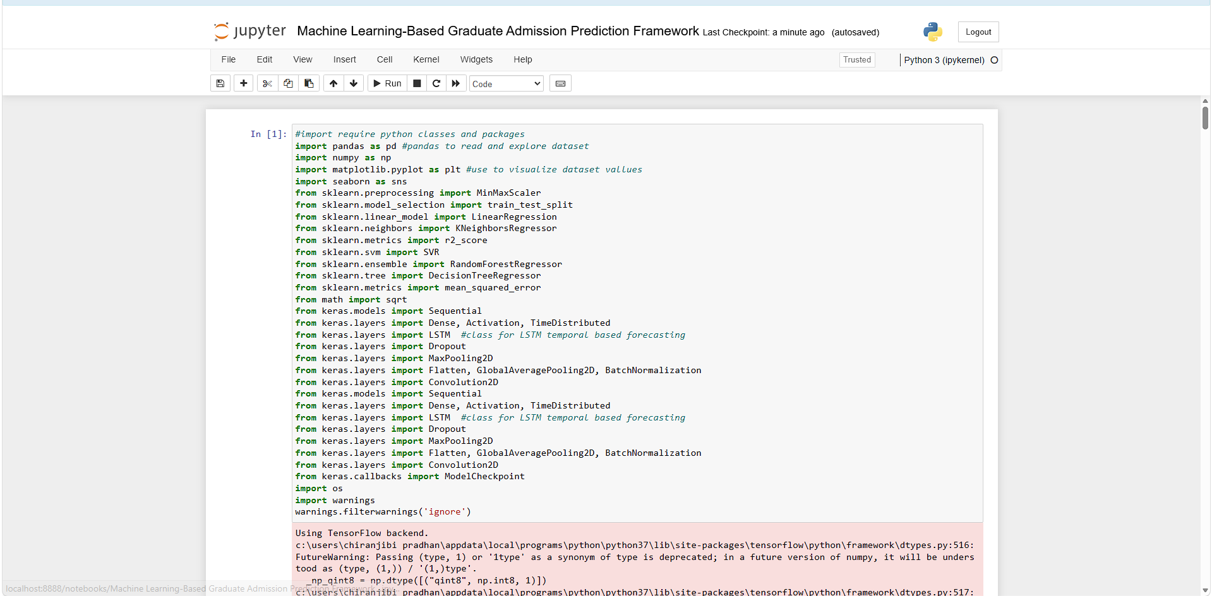
In above screen importing required packages and classes
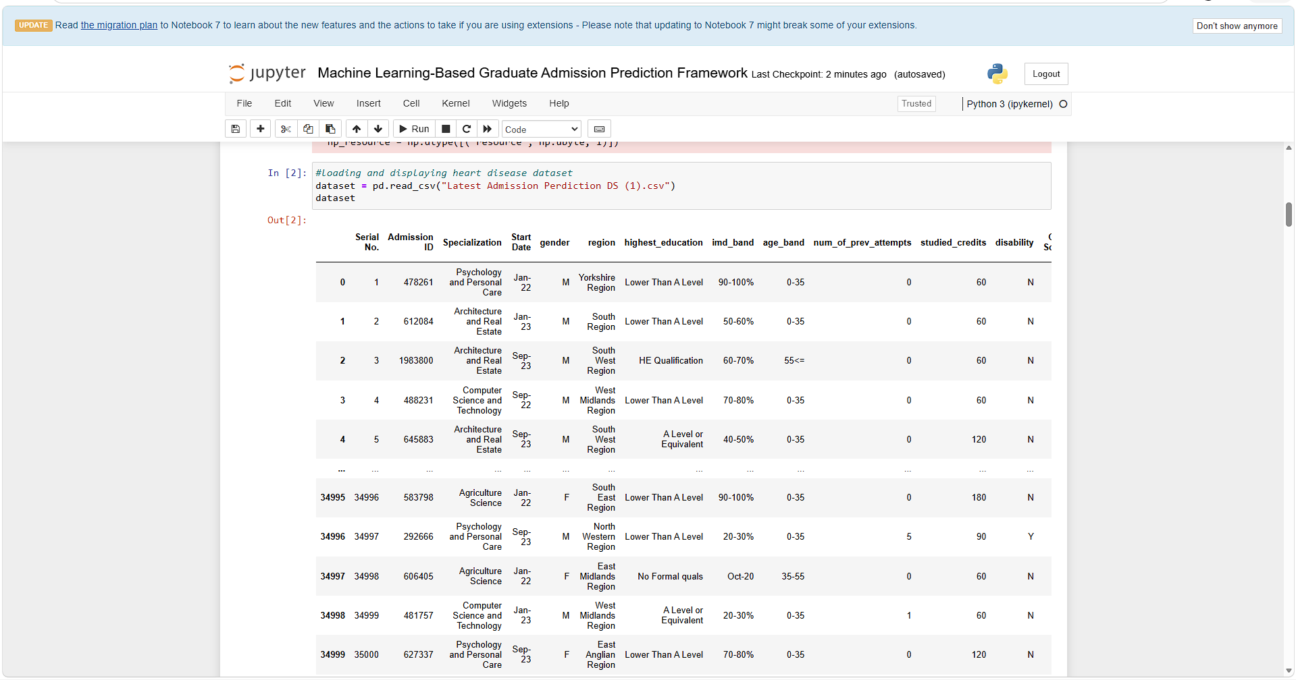
In above screen loading and displaying dataset values
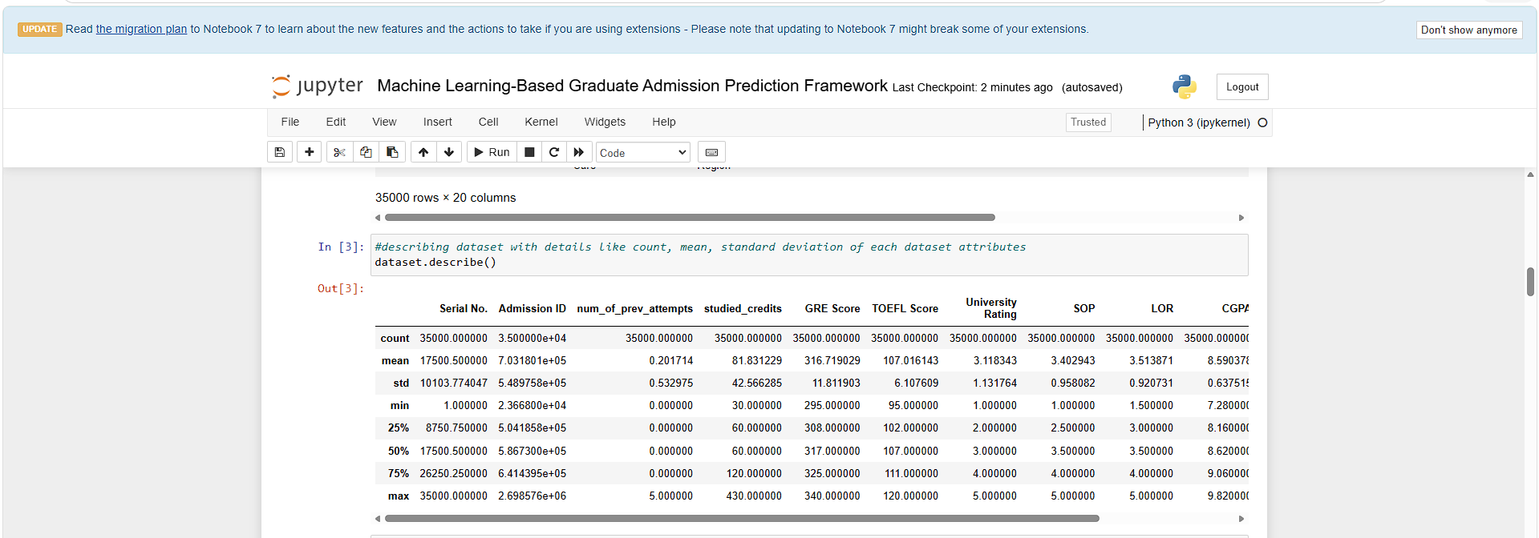
In above screen describing dataset with mean, count, standard deviation of each column.
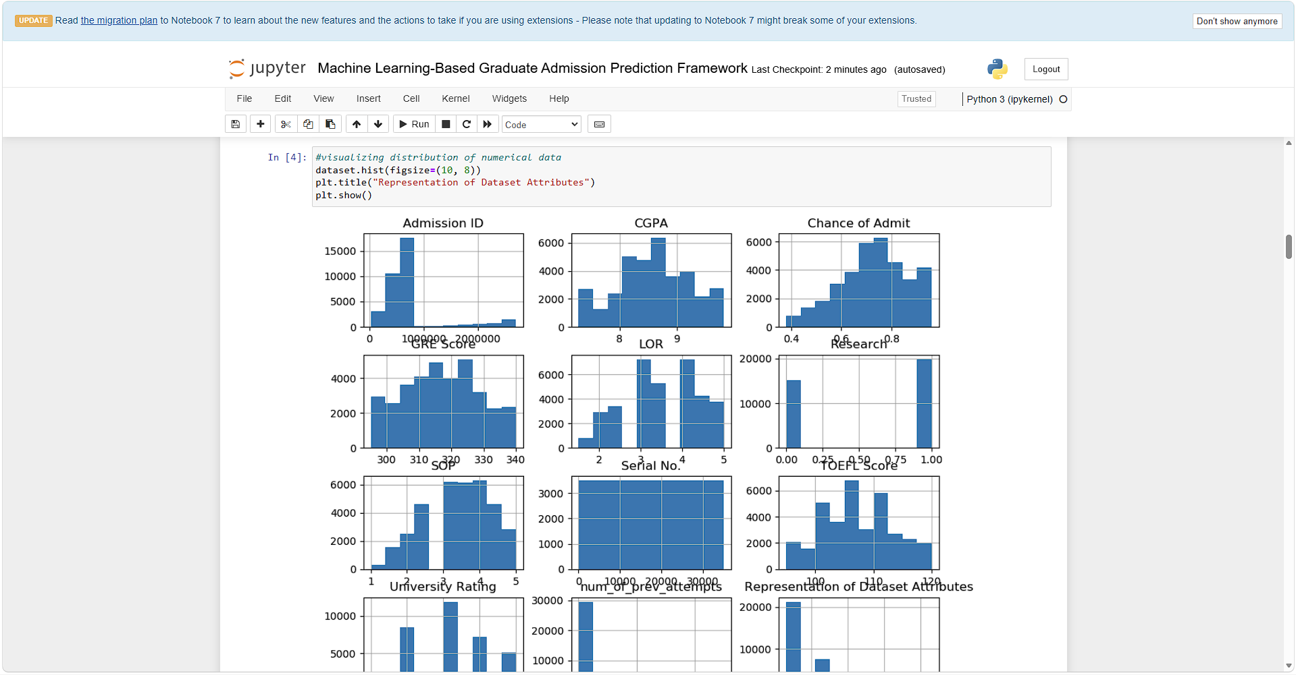
In above screen visualizing values of all columns based on their high and low values
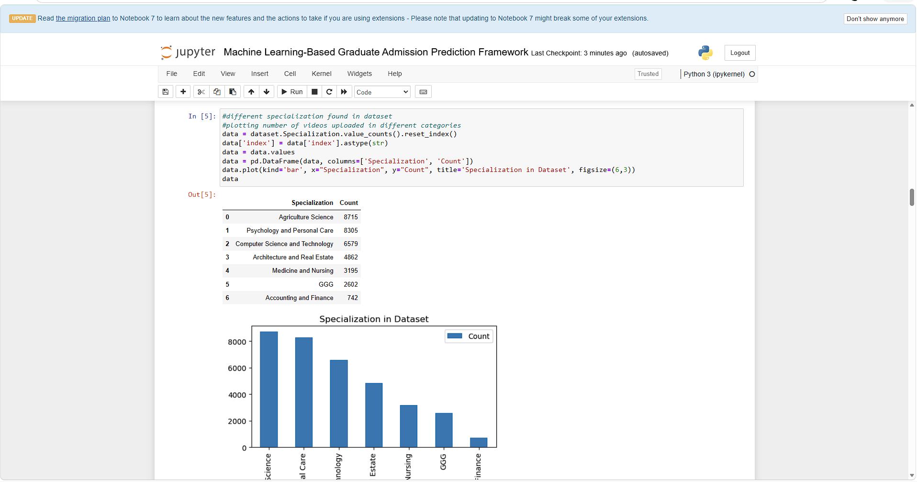
In above 2 screens displaying graph of different number of admissions done in different specialization where x-axis represents Specialization name and y-axis represents count
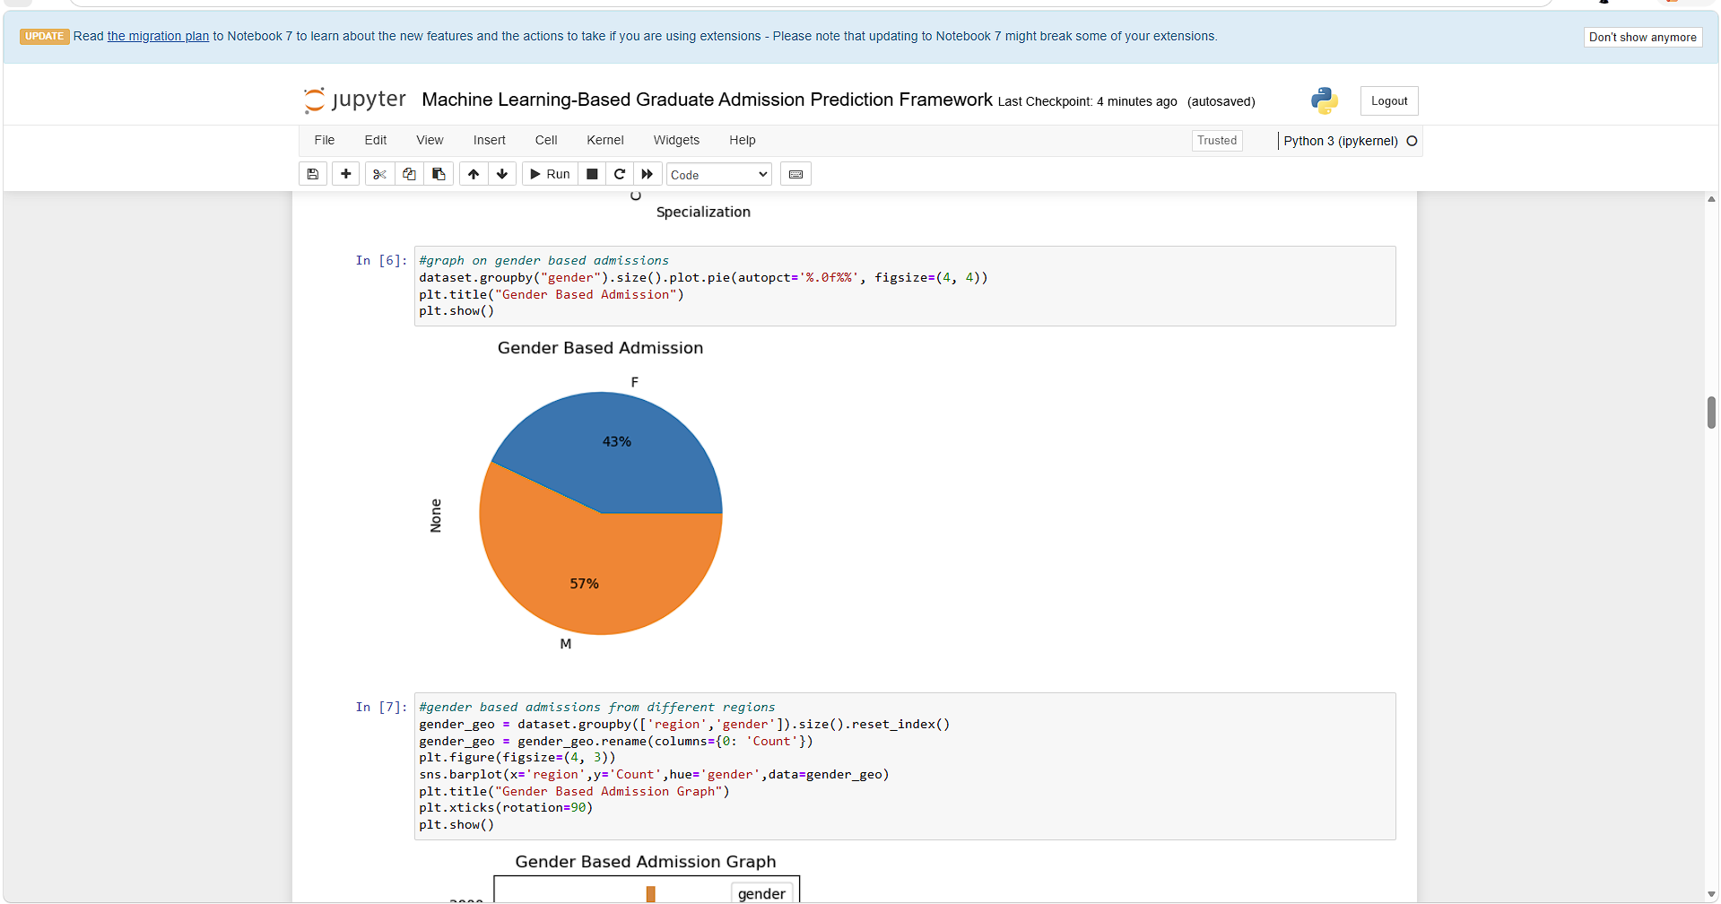
In above screen visualizing graph of number of admission taken by male and female gender
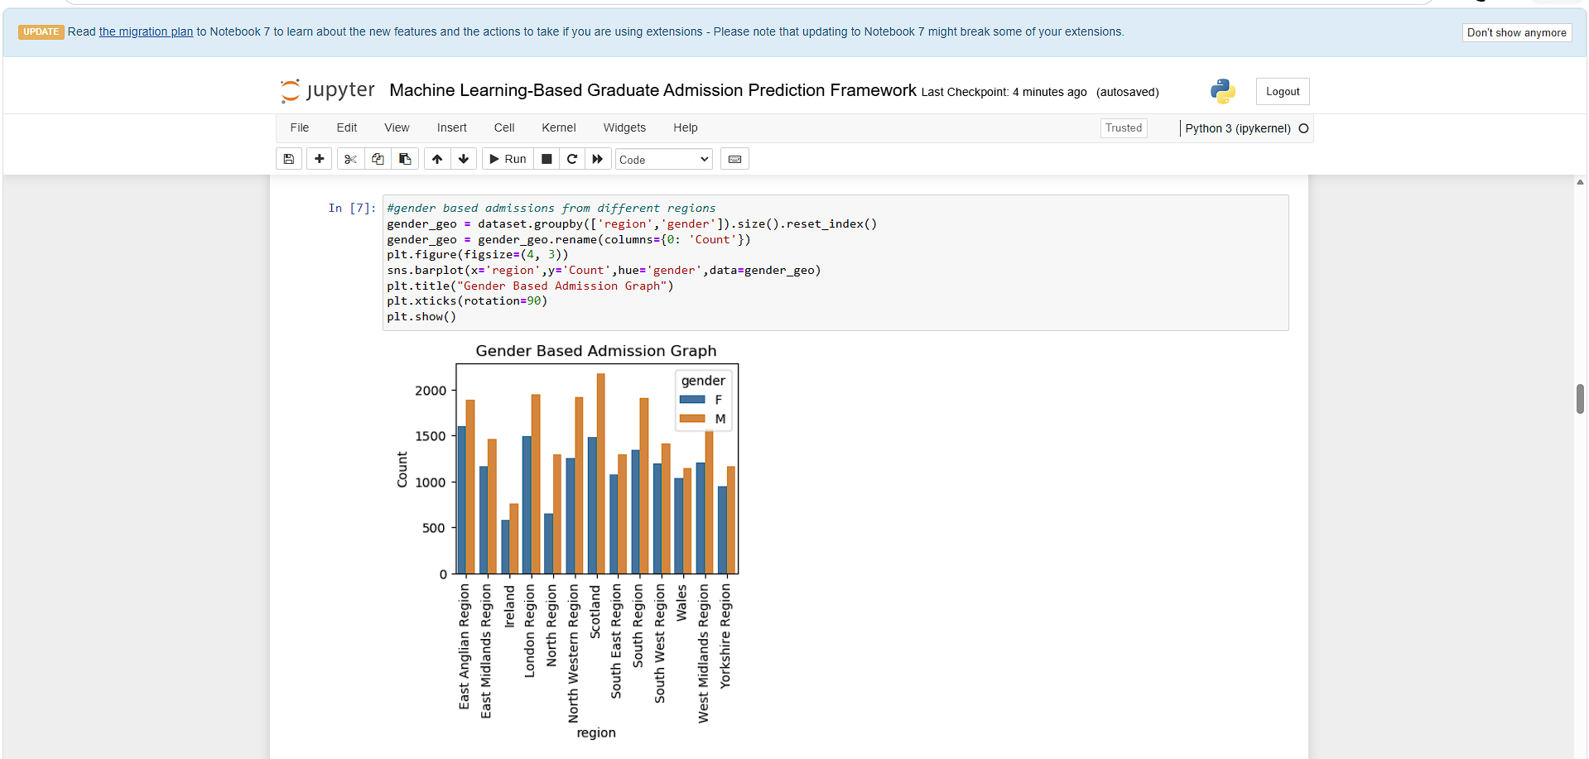
In above screen visualizing number of admission taken by gender from different regions where x-axis represents ‘Region Name’ and y-axis represents gender count
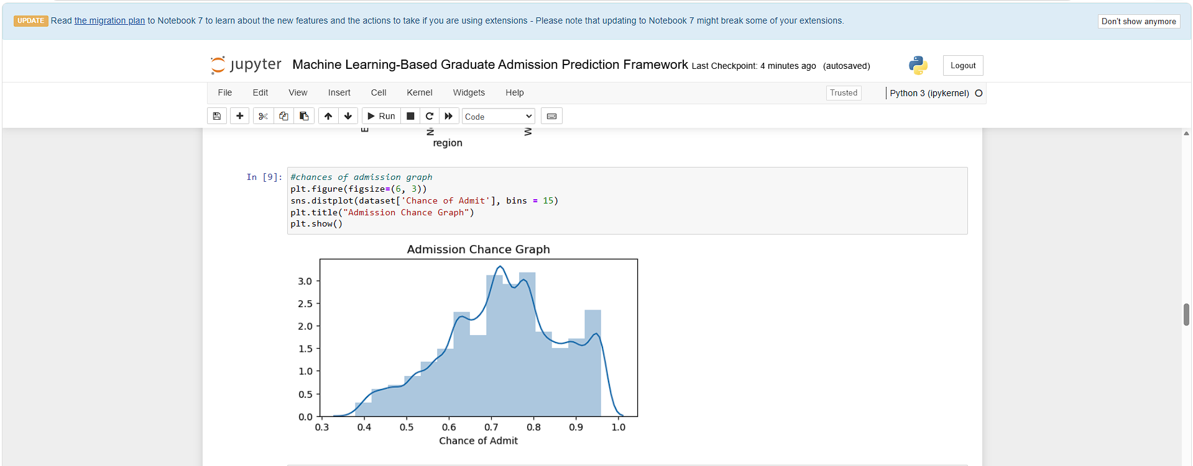
In above screen displaying graph of admission chances on different percentage
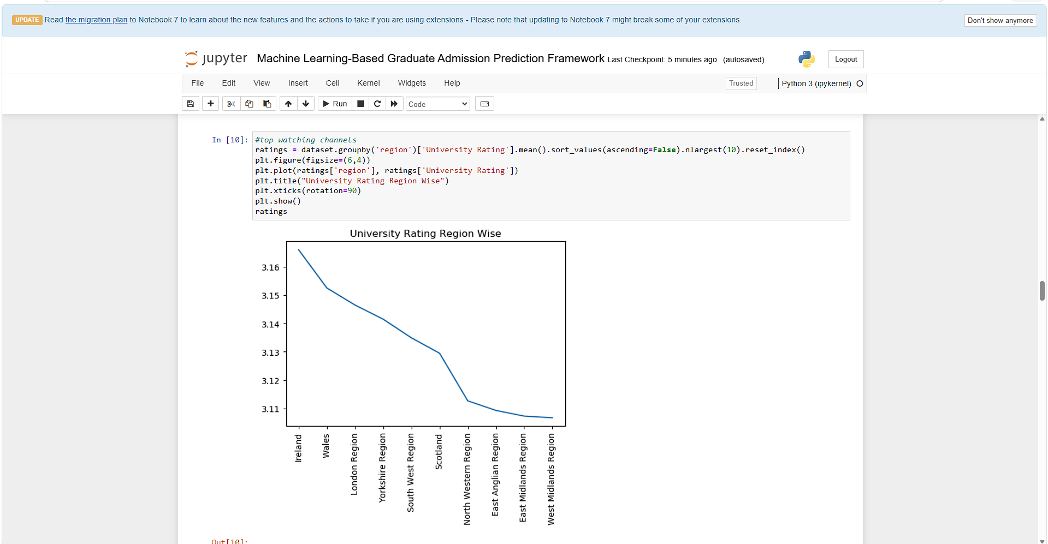
In above screen displaying graph of ratings of different regions universities where x-axis represents Region Name and y-axis represents ratings

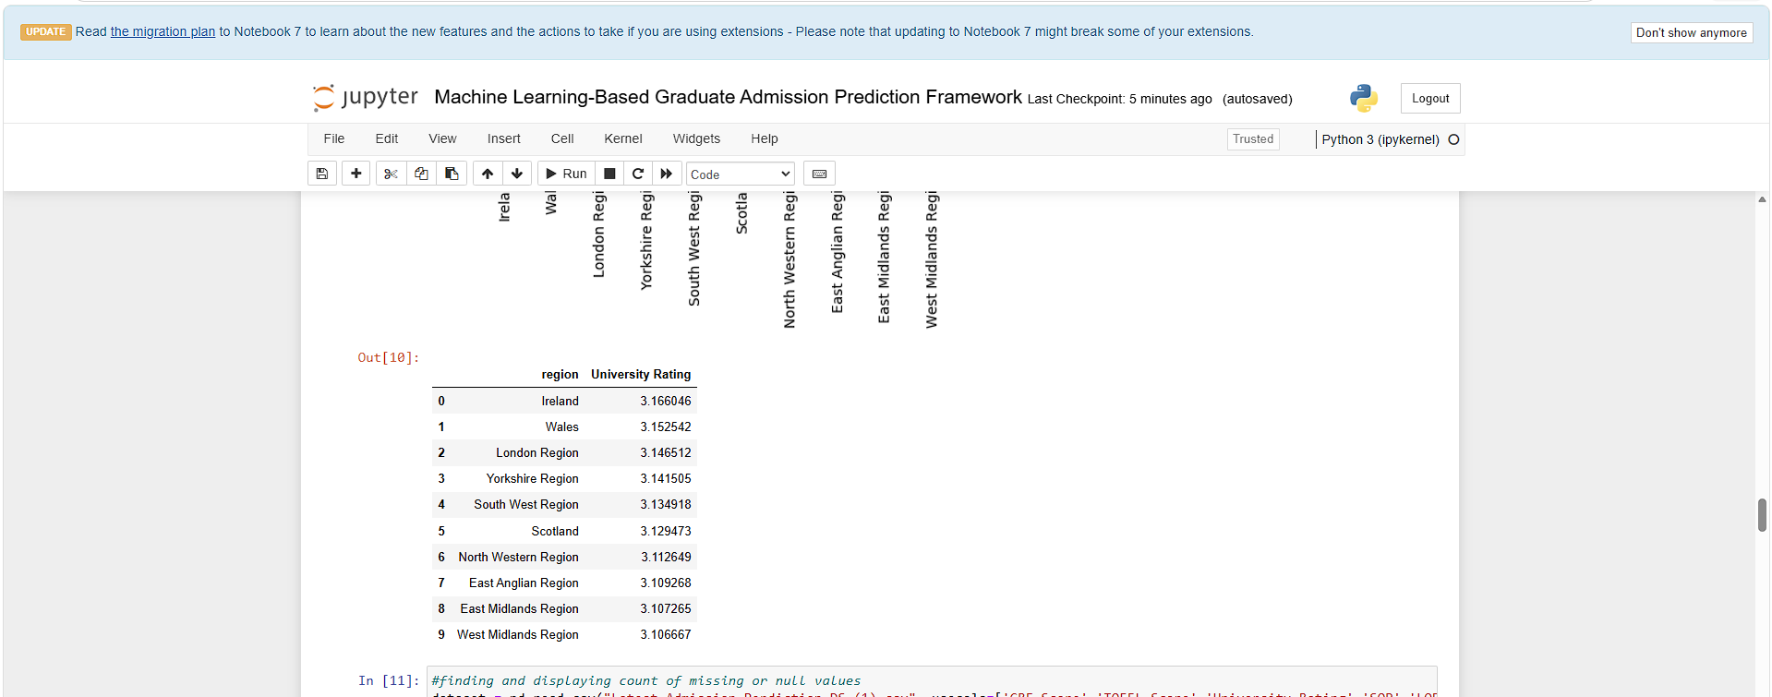
In above screen can see ratings of different regions university
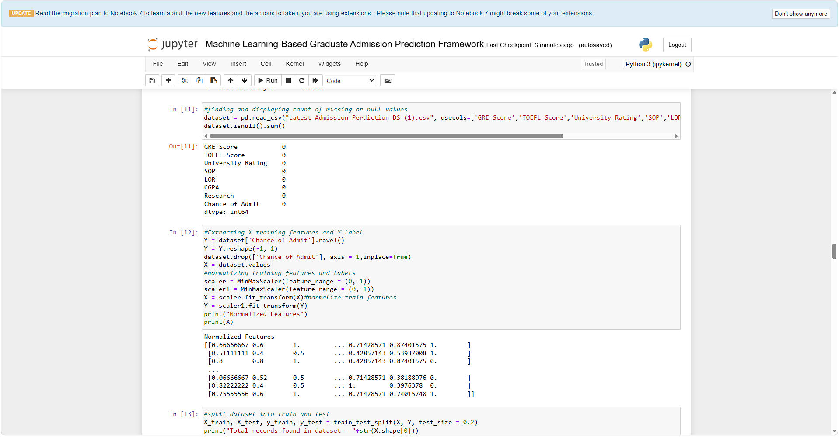
In above screen finding missing values from dataset but it contains 0 missing values and applying data processing and normalization
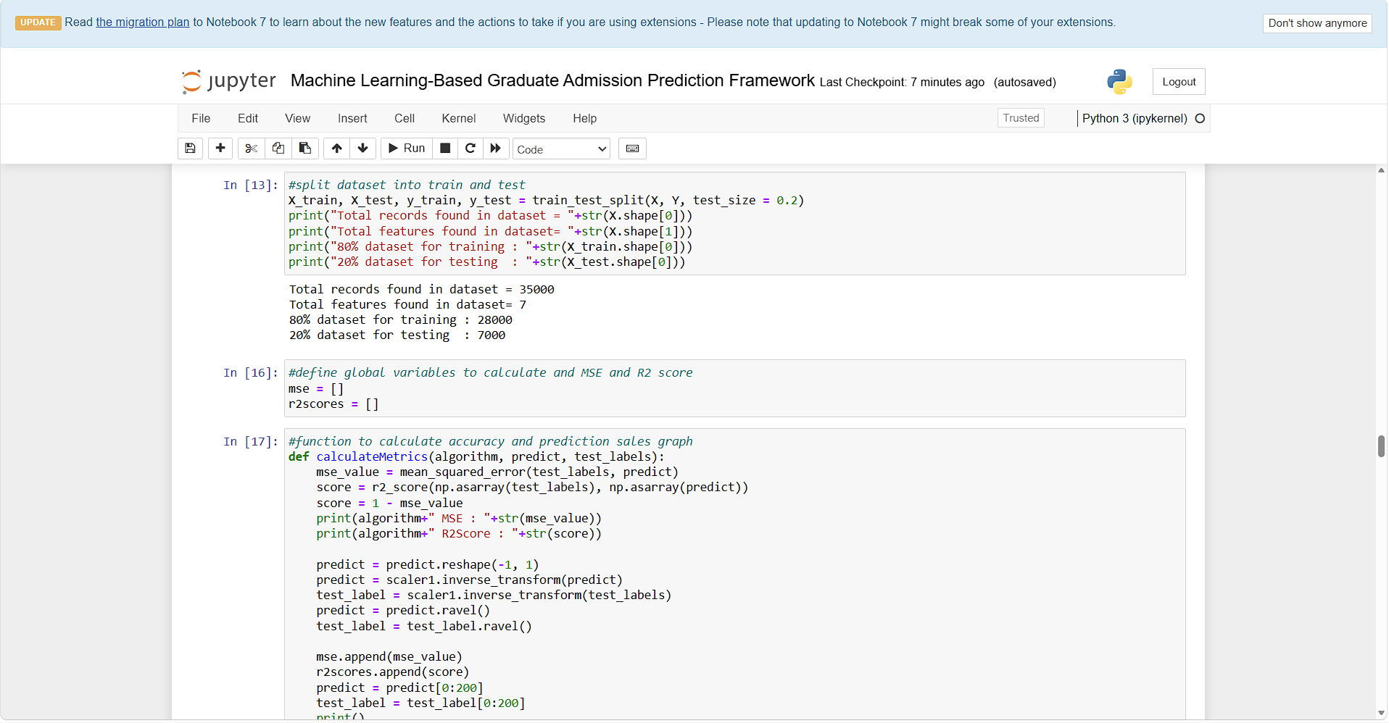
In above screen splitting processed dataset into train and test where application using 80% dataset for training and 20% for testing
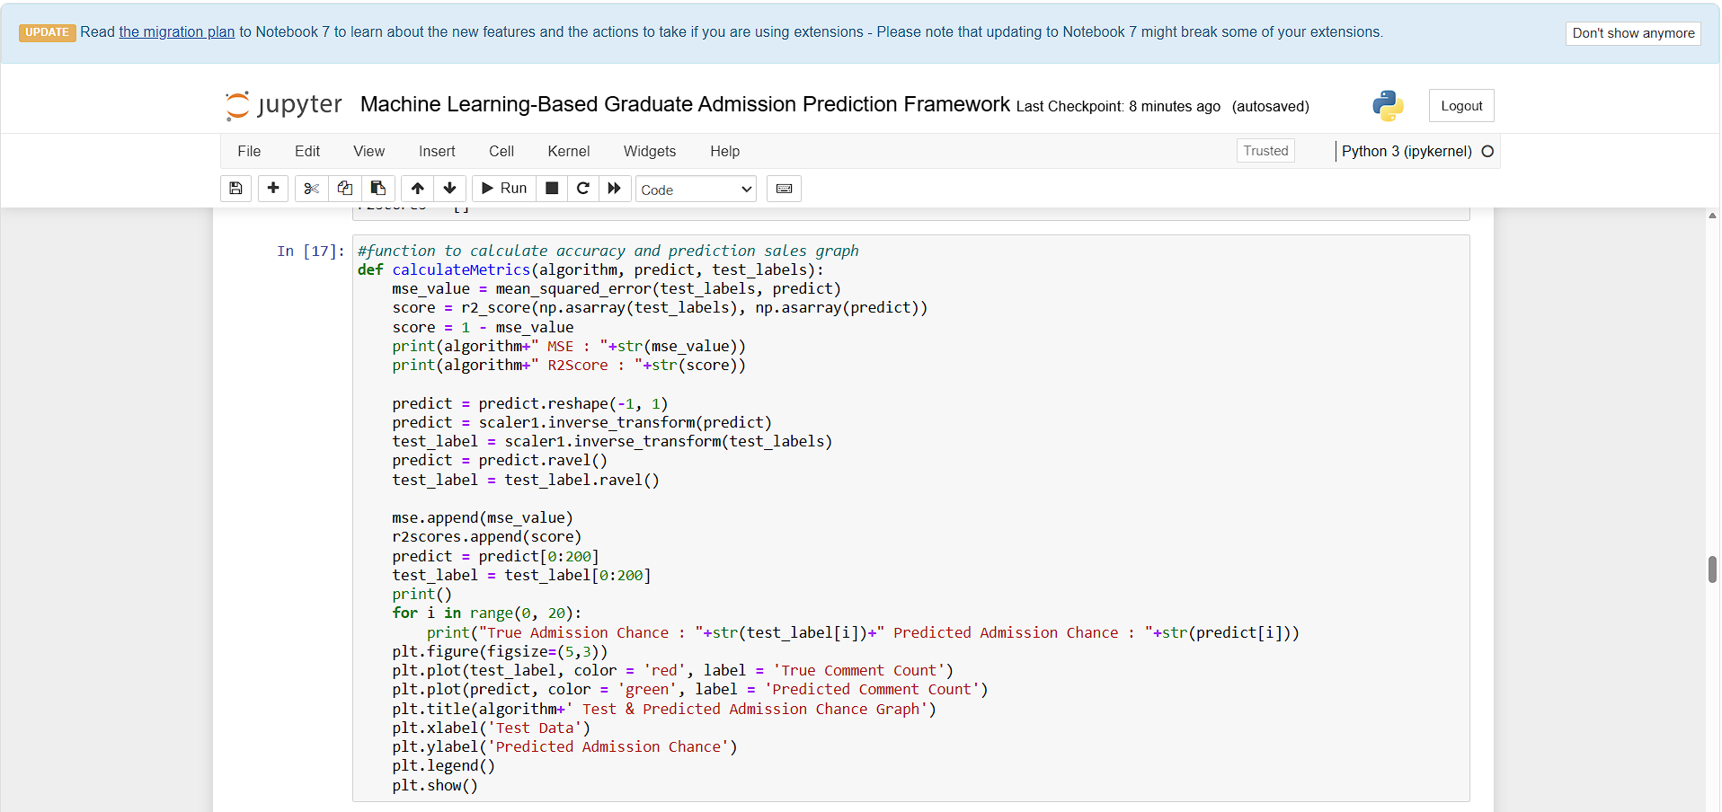
In above screen defining function to calculate MSE and R2SCORE from predicted and test labels
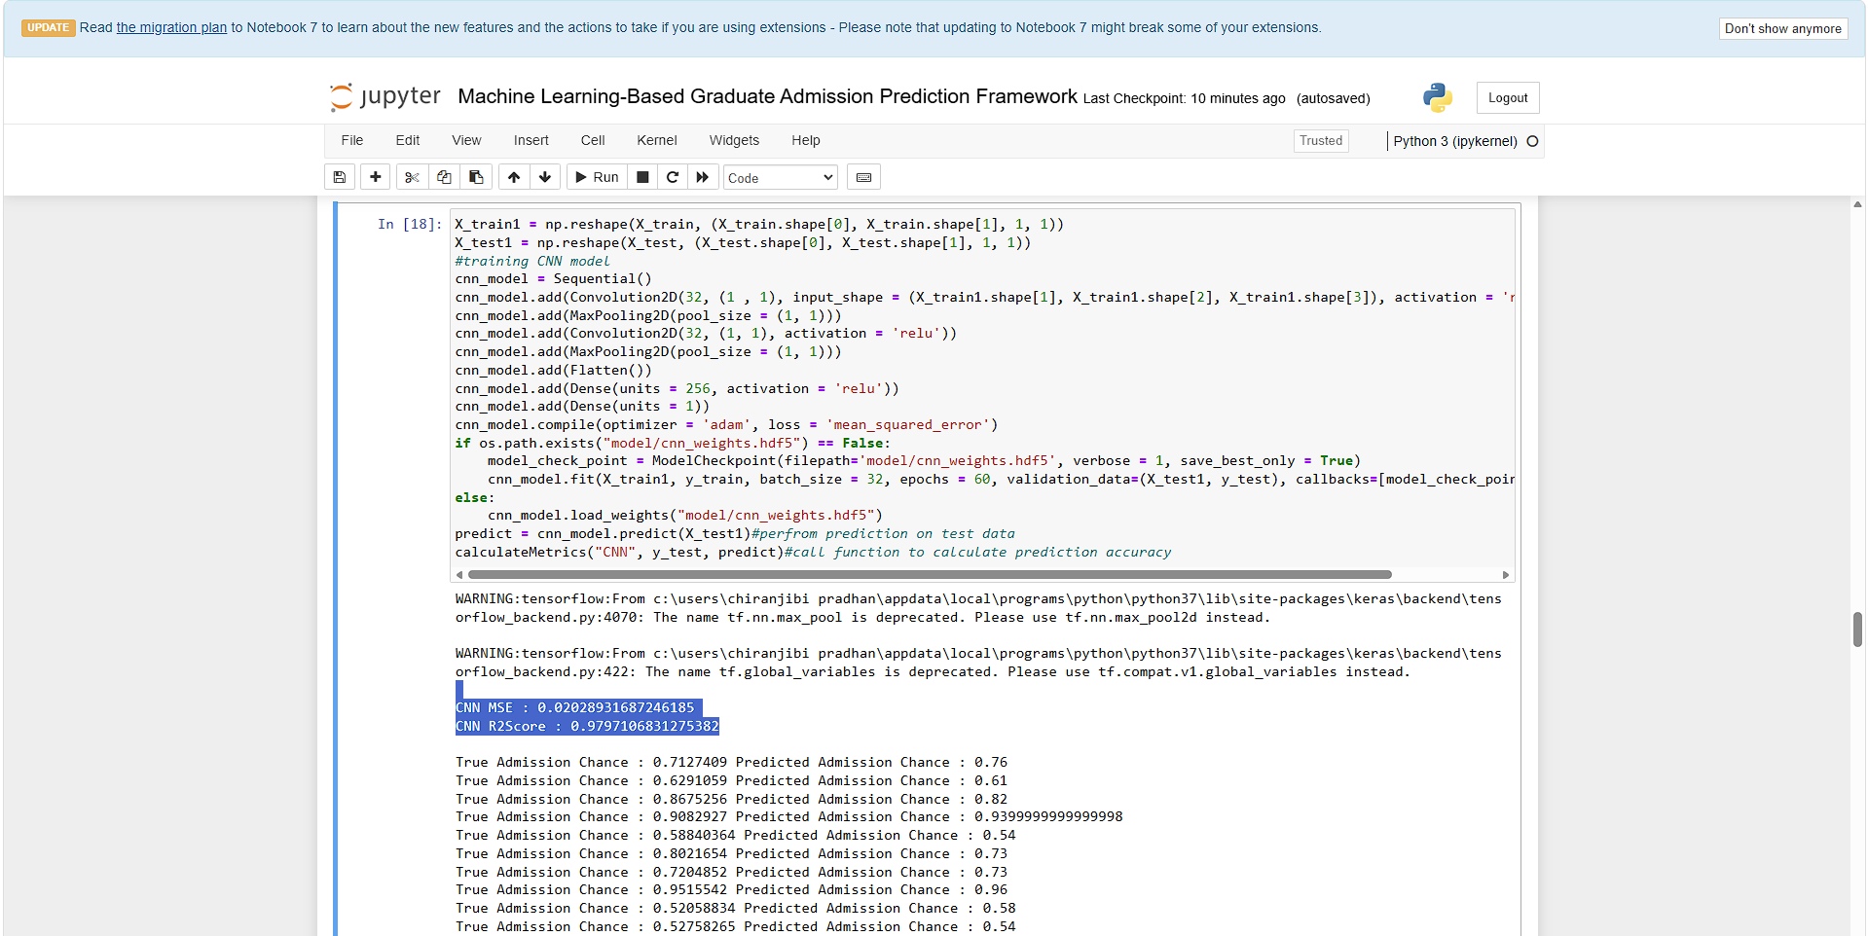
In above screen training CNN algorithm and after executing above block will get output and CNN got 0.018 as the MSE and 98.11 as the R2 score and then can see test data admission percentage and predicted admission percentage which is very close
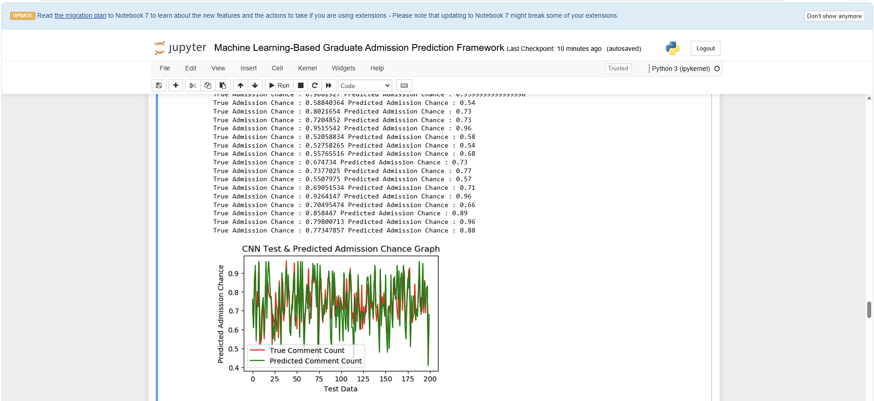
In above CNN prediction graph where x-axis represents Test Data count and y-axis represents admission percentage. Red line represents Test data admission percentage and green line represents predicted admission percentage and can see both lines are fully overlapping with tiny gap so we can say CNN is more accurate in admission percentage prediction
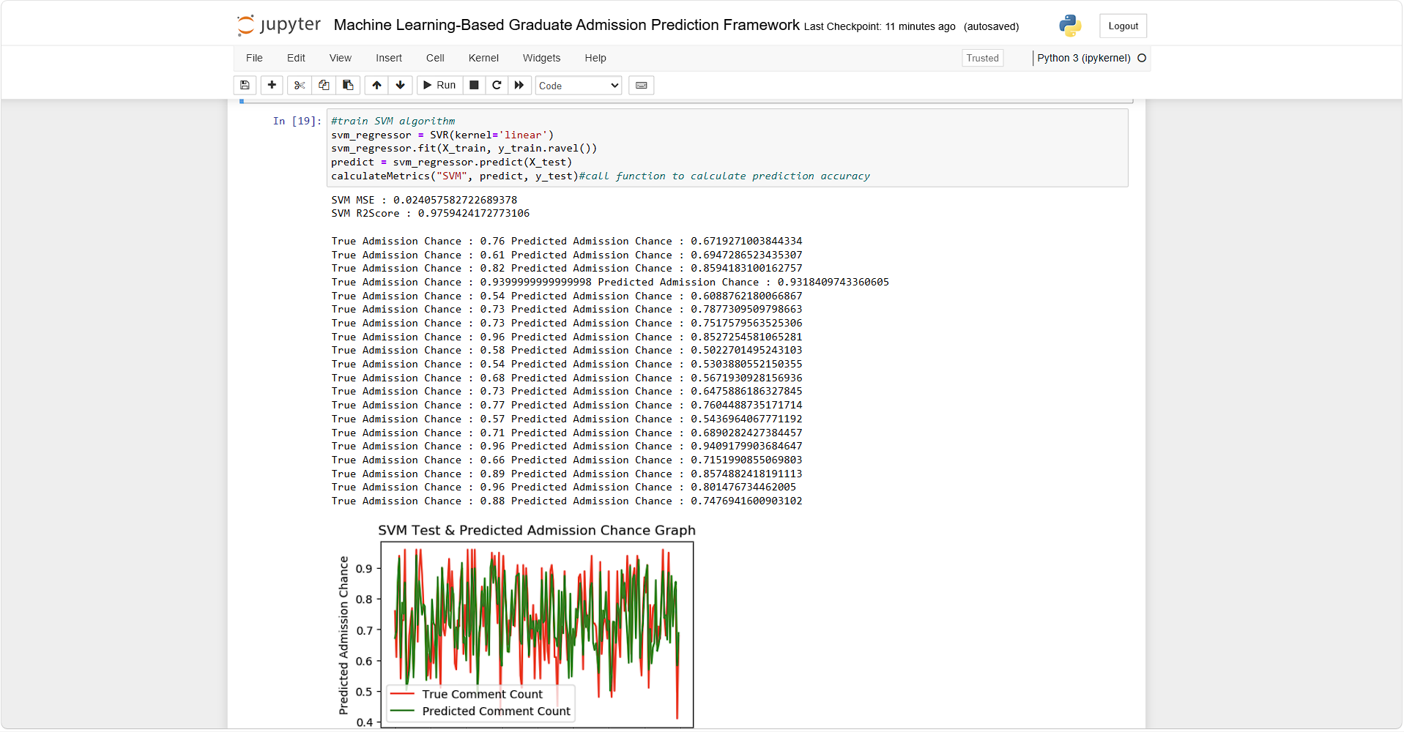
In above screen SVM got 0.97% as the R2SCORE and can see predicted and true percentage and below is the graph and SVM prediction is little un-accurate as both lines has major gap
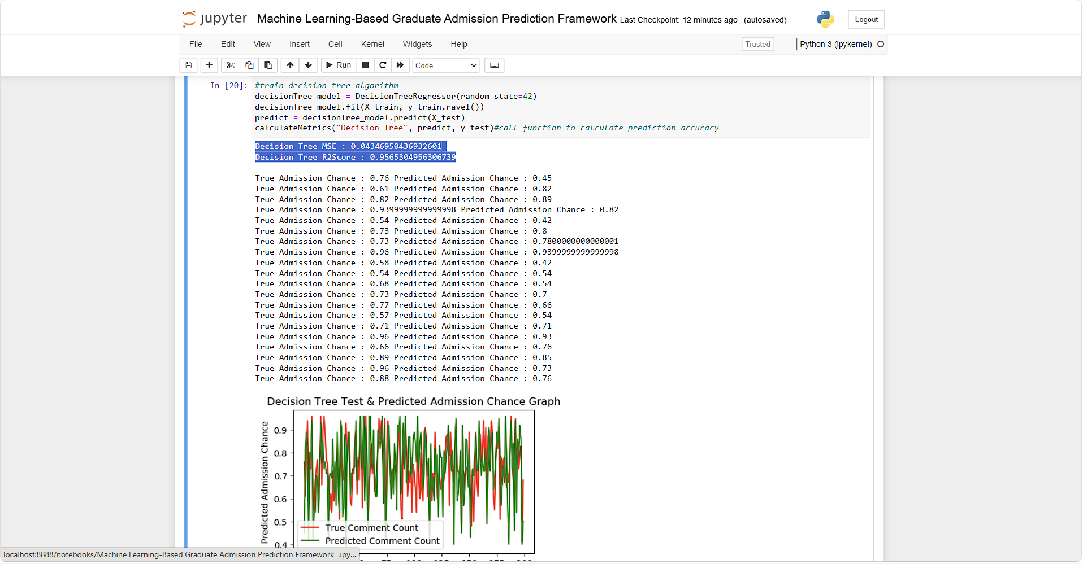
In above screen training decision tree and it got 95% R2SCORE
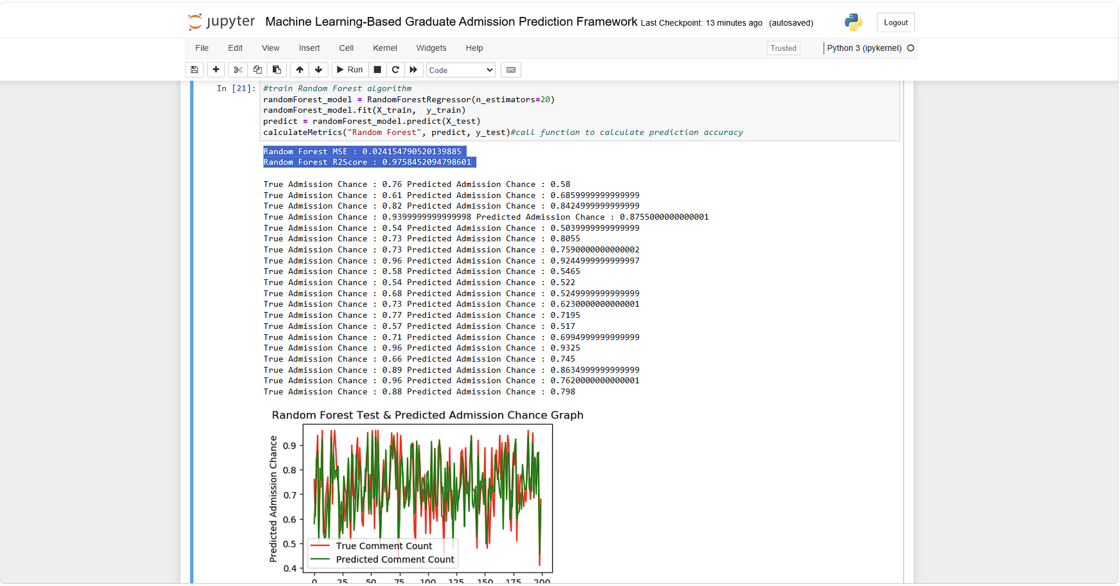
In above screen Random Forest got 97% R2Score
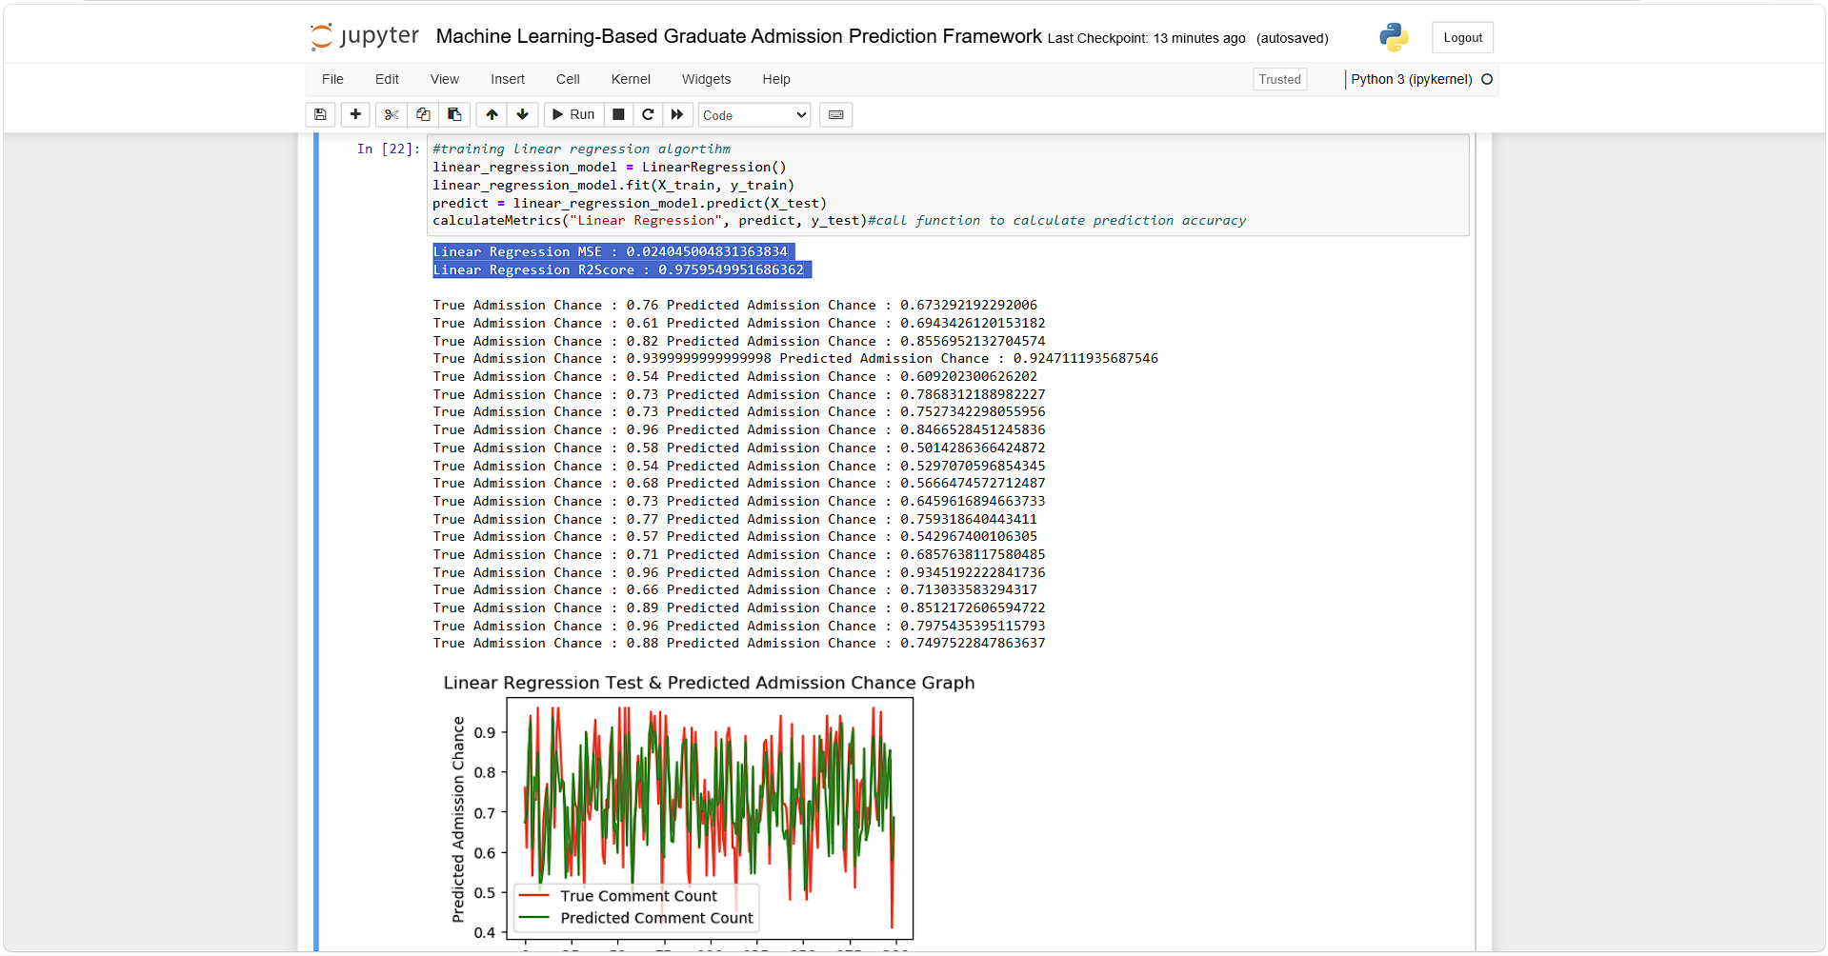
In above screen Linear Regression got 0.97% R2Score
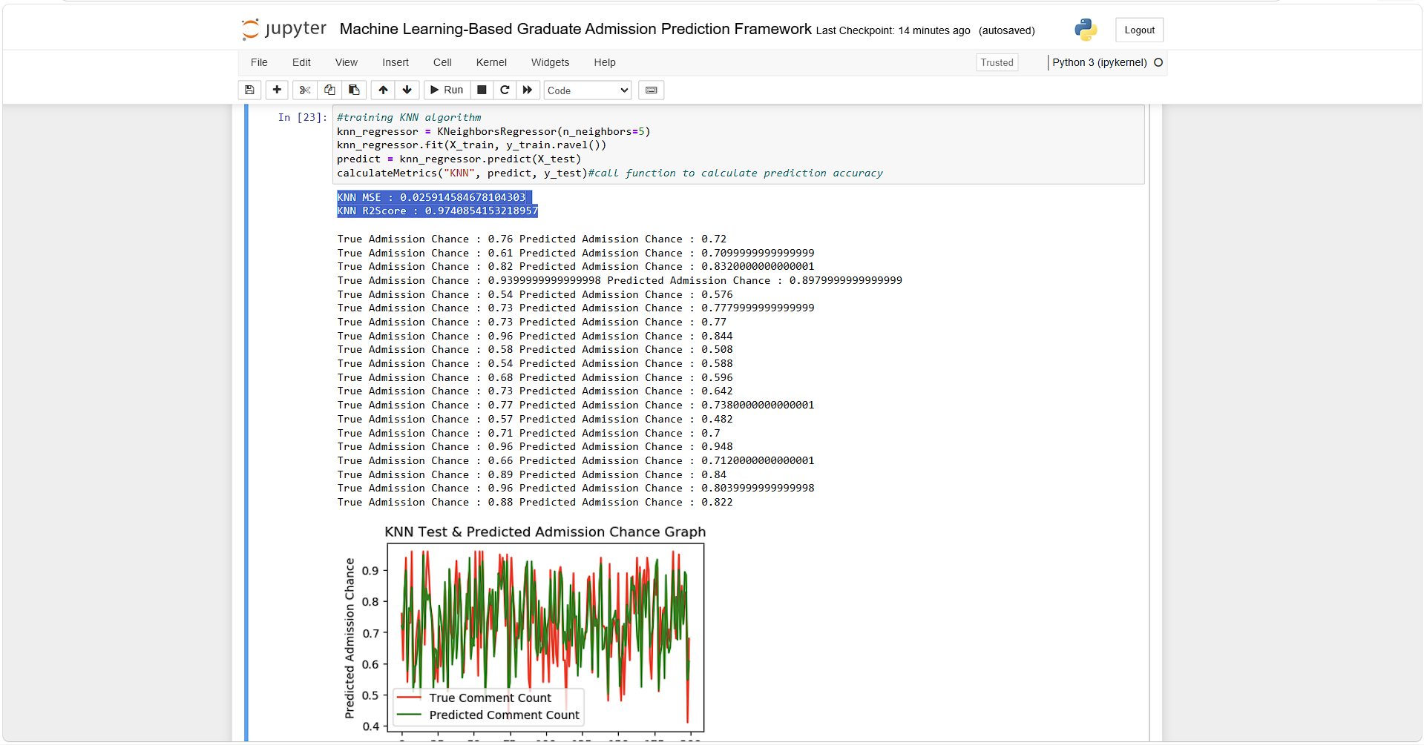
In above screen KNN got 97% R2Score
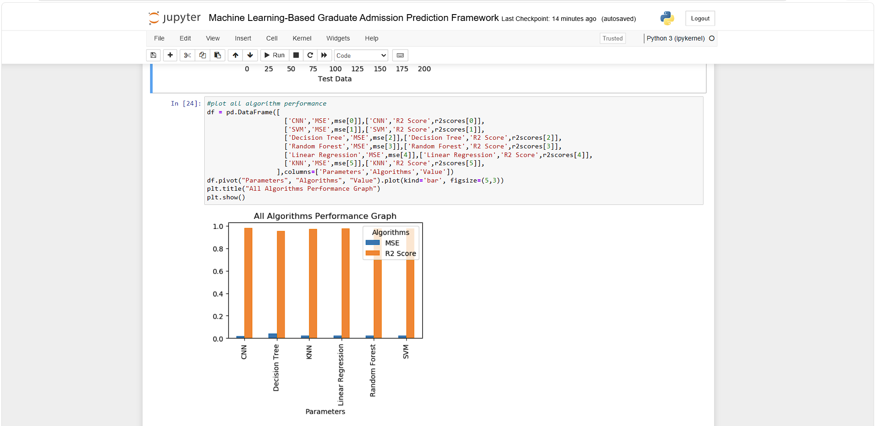
In above screen displaying all algorithm performance graph where x-axis represents algorithm names and y-axis represents MSE and R2score in different color bars and in all algorithm CNN got high R2 score and less MSE score
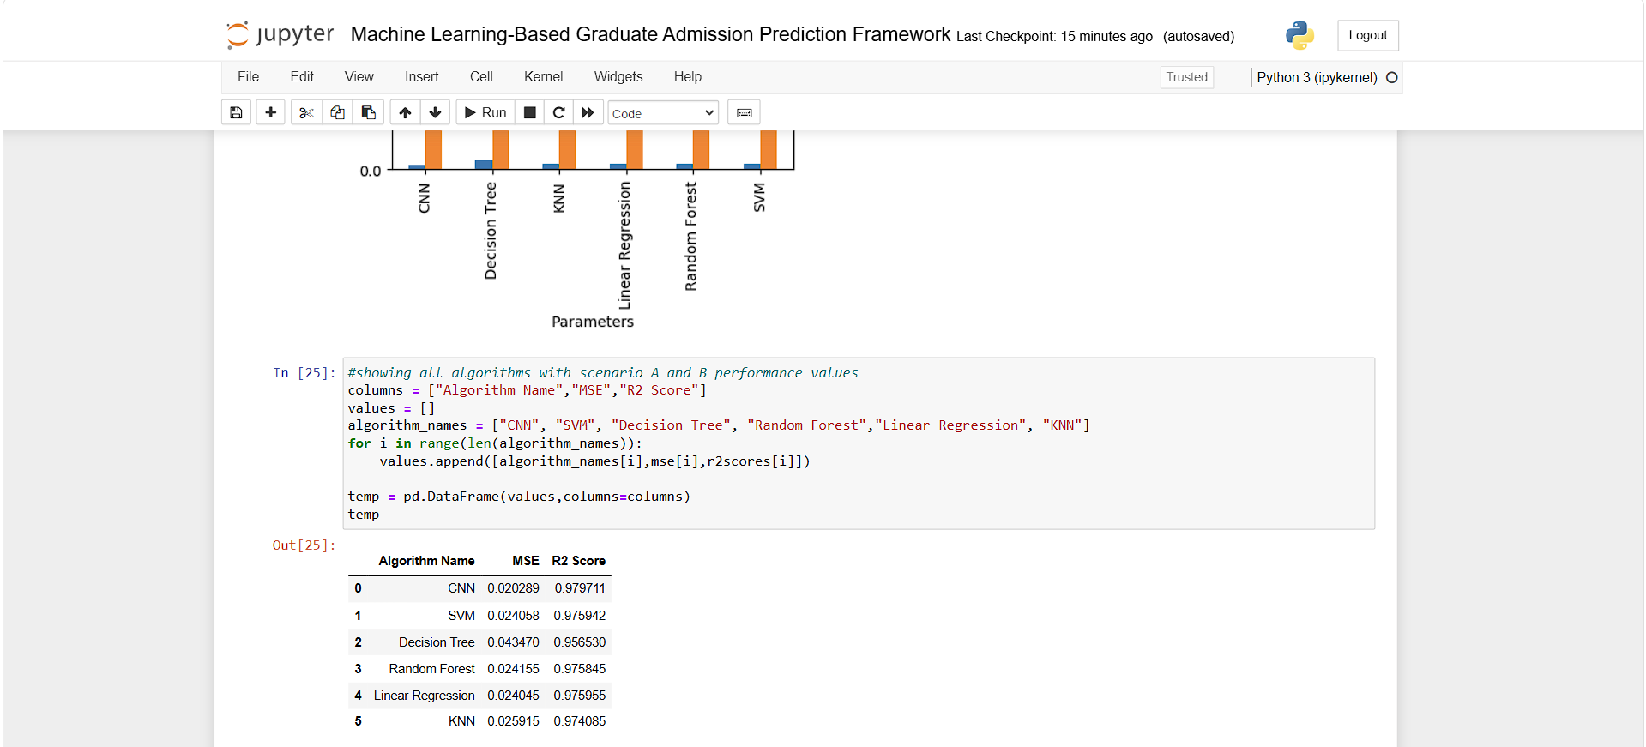
In above screen can see all algorithm performance in tabular format
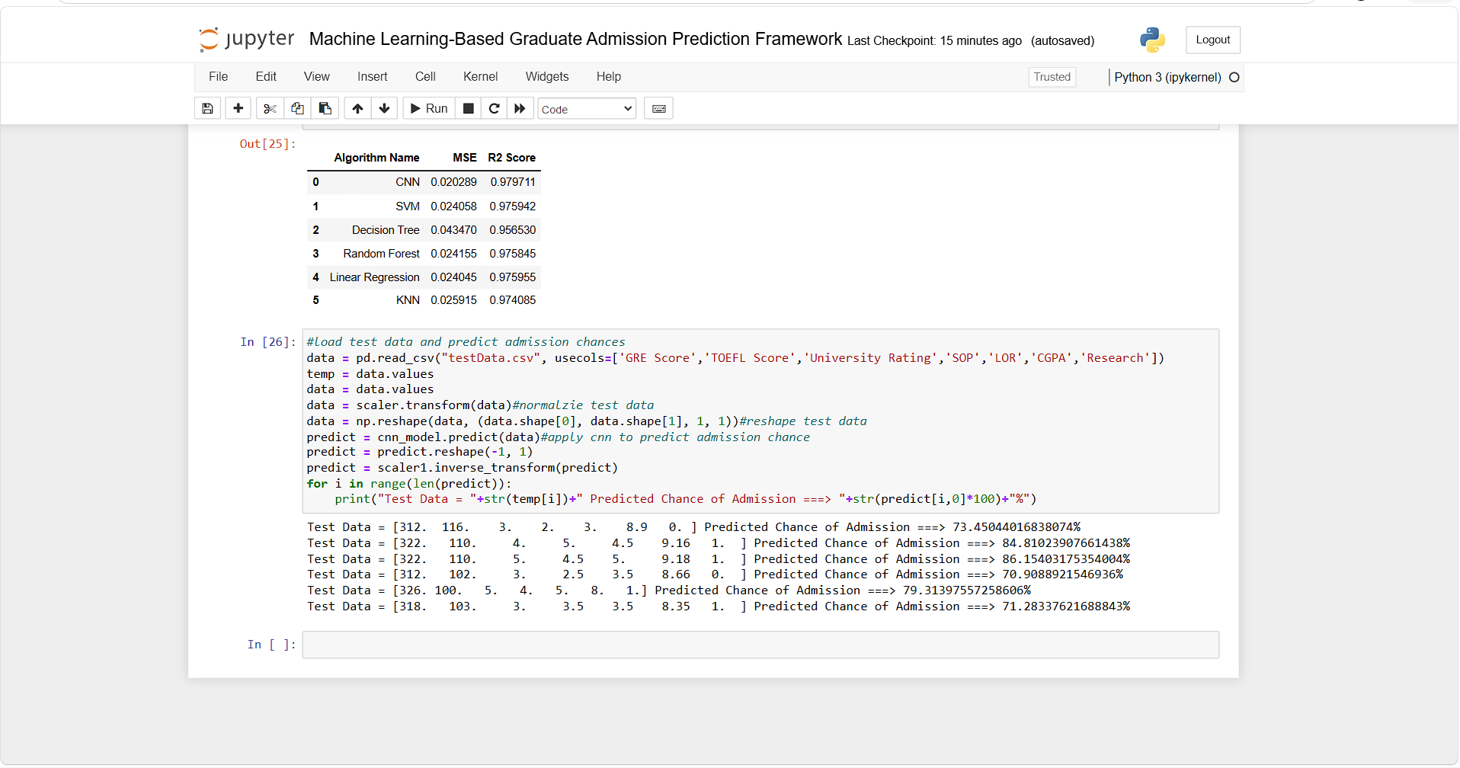
In above screen uploading test data file and then CNN predicting admission percentage and in above output square bracket contains test data and after = symbol can see predicted admission percentage.
CONCLUSION:
The Machine Learning-Based Graduate Admission Prediction Framework provides a structured approach for analyzing graduate admission data and predicting admission percentages using machine learning and deep learning techniques. The framework performs dataset analysis, visualization, preprocessing, normalization, and an 80:20 training-testing split before applying CNN2D, SVM, Decision Tree, Random Forest, KNN, and Linear Regression algorithms. The experimental results show that the CNN2D model achieved an MSE of 0.018 and an R² score of 98.11, with its predicted admission percentages closely matching the actual test values. The comparative evaluation using MSE and R² demonstrates the usefulness of analyzing multiple algorithms for admission prediction. The framework also supports uploading test data and generating admission percentage predictions using the trained CNN2D model. Overall, the system demonstrates the applicability of machine learning and deep learning for educational data analysis and data-driven graduate admission prediction.
FUTURE SCOPE:
- Integration of Additional Machine Learning Models – Future versions can evaluate additional machine learning and deep learning algorithms to further study their effectiveness for graduate admission prediction.
- Larger and More Diverse Datasets – The framework can be extended with larger datasets containing admission records from more universities, specializations, regions, and academic backgrounds.
- Advanced Feature Analysis – Future work can incorporate additional admission-related attributes and advanced feature-selection techniques to identify the most relevant factors influencing admission percentage.
- Web-Based Prediction Enhancement – The existing test-data prediction functionality can be developed into a more interactive web-based system that allows users to enter applicant information directly and obtain admission predictions.
- Advanced Model Optimization – Future research can explore hyperparameter optimization and improved CNN2D architectures to investigate whether prediction performance can be further improved while maintaining reliable MSE and R² results.

REFERENCES:
- S. Ghosh and A. Dey, “Predicting Chance of Admission: A Machine Learning Perspective,” 2025 International Conference on Computing, Intelligence, and Application (CIACON), 2025, DOI: 10.1109/CIACON65473.2025.11189394.
- S. Nalam, M. Aleemuddin, Y. T. Kadari, and N. K. Mungaru, “Advanced Graduate Admission Prediction,” 2023 IEEE 8th International Conference for Convergence in Technology (I2CT), 2023, DOI: 10.1109/I2CT57861.2023.10126307.
- S. Aljasmi, A. Bou Nassif, I. Shahin, and A. M. Elnagar, “Graduate Admission Prediction Using Machine Learning,” International Journal of Computers and Communications, vol. 14, pp. 79–83, 2020, DOI: 10.46300/91013.2020.14.13.
- M. N. Injadat, A. Moubayed, A. B. Nassif, and A. Shami, “Systematic Ensemble Model Selection Approach for Educational Data Mining,” Knowledge-Based Systems, vol. 200, Art. no. 105992, 2020, DOI: 10.1016/j.knosys.2020.105992.
- Z. Bitar and A. Al-Mousa, “Prediction of Graduate Admission Using Multiple Supervised Machine Learning Models,” 2020 IEEE SoutheastCon, 2020, DOI: 10.1109/SoutheastCon44009.2020.9249747.
- M. S. Acharya, A. Armaan, and A. S. Antony, “A Comparison of Regression Models for Prediction of Graduate Admissions,” 2019 Second International Conference on Computational Intelligence in Data Science (ICCIDS), 2019, DOI: 10.1109/ICCIDS.2019.8862140.
- N. K. Karki, “Predicting Graduate Admission from Important Parameters,” Technical Report, 2019, DOI: 10.13140/RG.2.2.28795.07206.
- A. Waters and R. Miikkulainen, “GRADE: Machine Learning Support for Graduate Admissions,” AI Magazine, vol. 35, no. 1, pp. 64–75, 2014, DOI: 10.1609/aimag.v35i1.2504.
- N. Gupta, A. Sawhney, and D. Roth, “Will I Get in? Modeling the Graduate Admission Process for American Universities,” 2016 IEEE 16th International Conference on Data Mining Workshops (ICDMW), pp. 631–638, 2016, DOI: 10.1109/ICDMW.2016.0095.
- Y. Zhao, X. Chen, H. Xue, and G. M. Weiss, “A Machine Learning Approach to Graduate Admissions and the Role of Letters of Recommendation,” PLOS ONE, vol. 18, no. 10, Art. no. e0291107, 2023, DOI: 10.1371/journal.pone.0291107.
- C. J. Raman, U. Janani, P. Dharani, and V. Balaji, “Machine Learning Based University Admit Eligibility Predictor,” AIP Conference Proceedings, vol. 2802, Art. no. 120047, 2024, DOI: 10.1063/5.0181764.
- A. Priyadarshini, B. Martinez-Neda, and S. Gago-Masague, “Admission Prediction in Undergraduate Applications: An Interpretable Deep Learning Approach,” 2023 Fifth International Conference on Transdisciplinary AI (TransAI), pp. 135–140, 2023.
- G. Raftopoulos, G. Davrazos, and S. Kotsiantis, “Fair and Transparent Student Admission Prediction Using Machine Learning Models,” Algorithms, vol. 17, no. 12, Art. no. 572, 2024, DOI: 10.3390/a17120572.

